**CMPE 272 – ENTERPRISE SOFTWARE PLATFORM**

Vibhava Rayala

**FORCE.COM INTEGRATION WORKBOOK**

1. CREATING SALEFORCE ACCOUNT:

1.1 Open [www.developer.salesforce.com](http://www.developer.salesforce.com) and select login if you are an existing user.

1.2 If you are a new user, select sign up and give your name and email id.

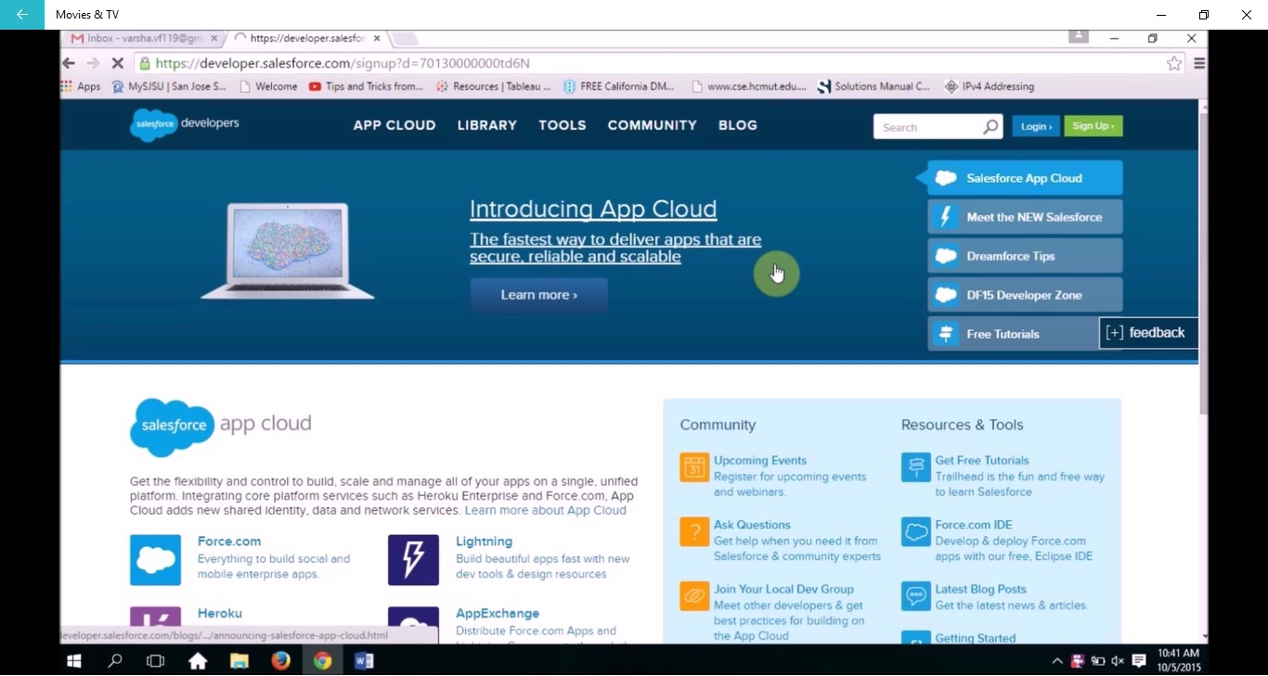

1.3 A verification mail will be sent. Open your email and verify it.

1.4 Set up a password and answer to the security question.

2. CREATING AN APPLICATION:

2.1 Under getting started select add app.

2.2 Give a name to your app and create an event under it. Give a unique name to it.

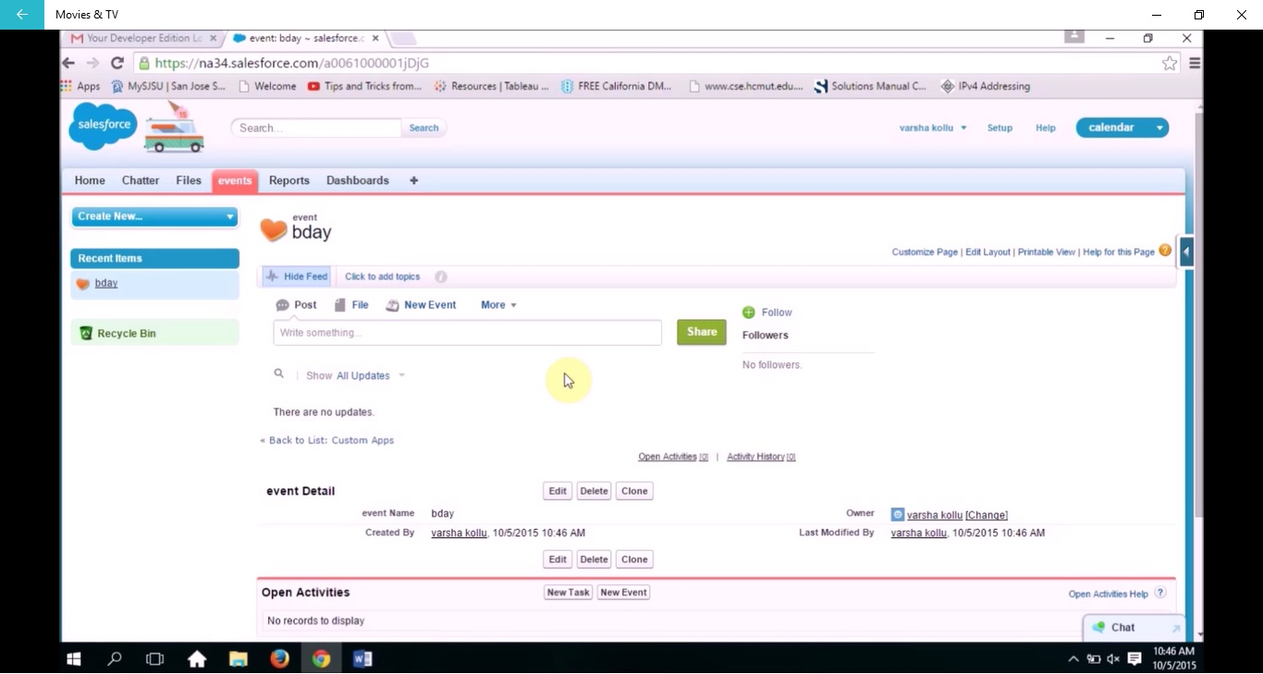

3. ENABLING API ACCESS:

3.1 In the top right corner select setup option.

3.2 Go to manage users -> users -> permission sets. Select edit.

3.3 Select API enabled and then add. Click save to save the changes.

4. CREATING EVENTS:

4.1 Select home. Click on the left arrow on the right side of the page and select view fields.

4.2 Under custom fields and relations select new.

4.3 Choose the field type and select next.

4.4 Give a label to the field and then select save. Do the same thing if you want to add more fields.

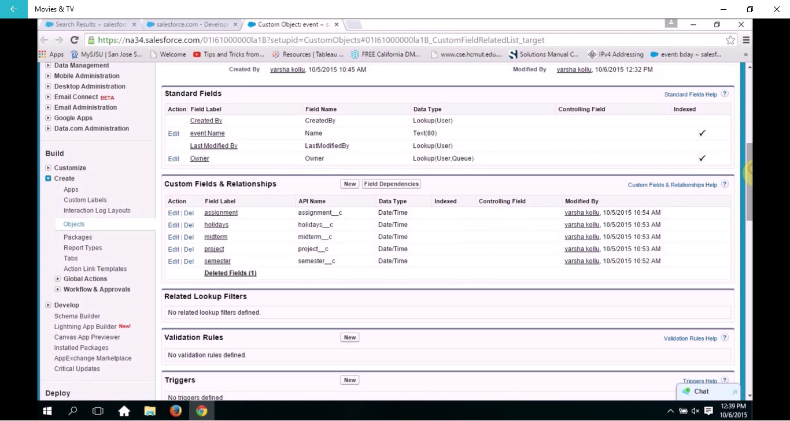

4.5 Go to home and select the event name and then click edit. This allows you to give details to your fields.

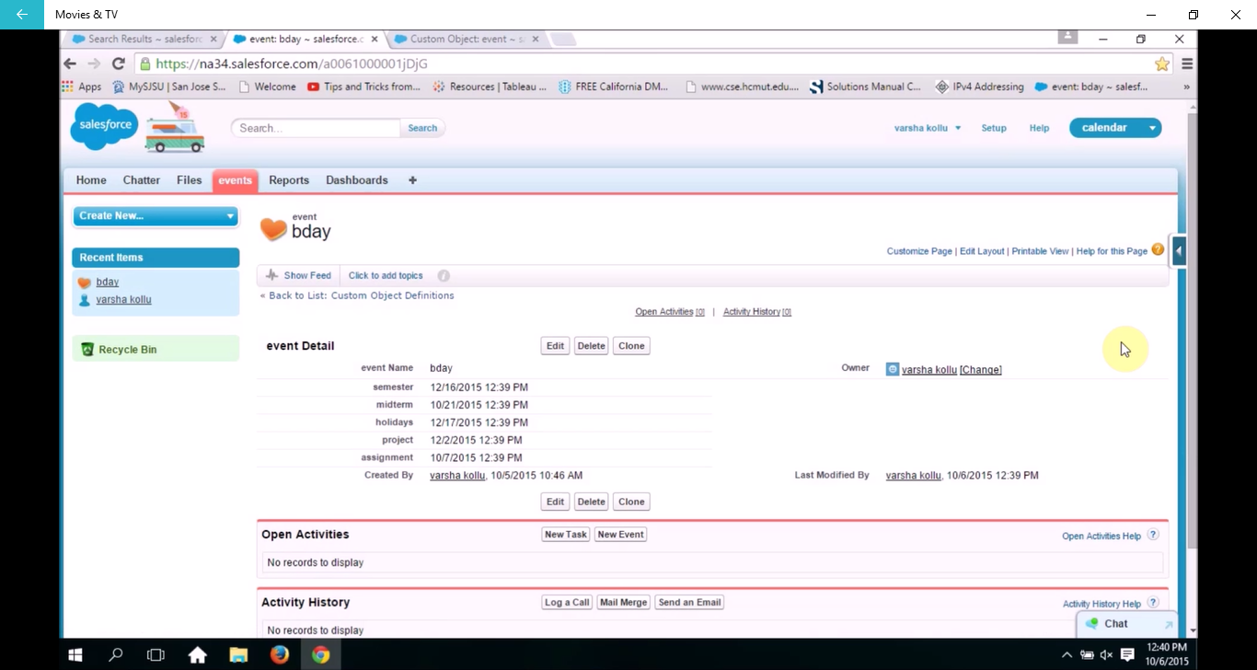

5. CREATING HEROKU APPLICATION:

5.1 Change to a directory where you want to download the example app and execute the command git clone <https://github.com/sbob-sfdc/spring-mvc-fulfillment-base>. Git downloads the existing project into a new folder, spring-mvc-fulfillment-base.

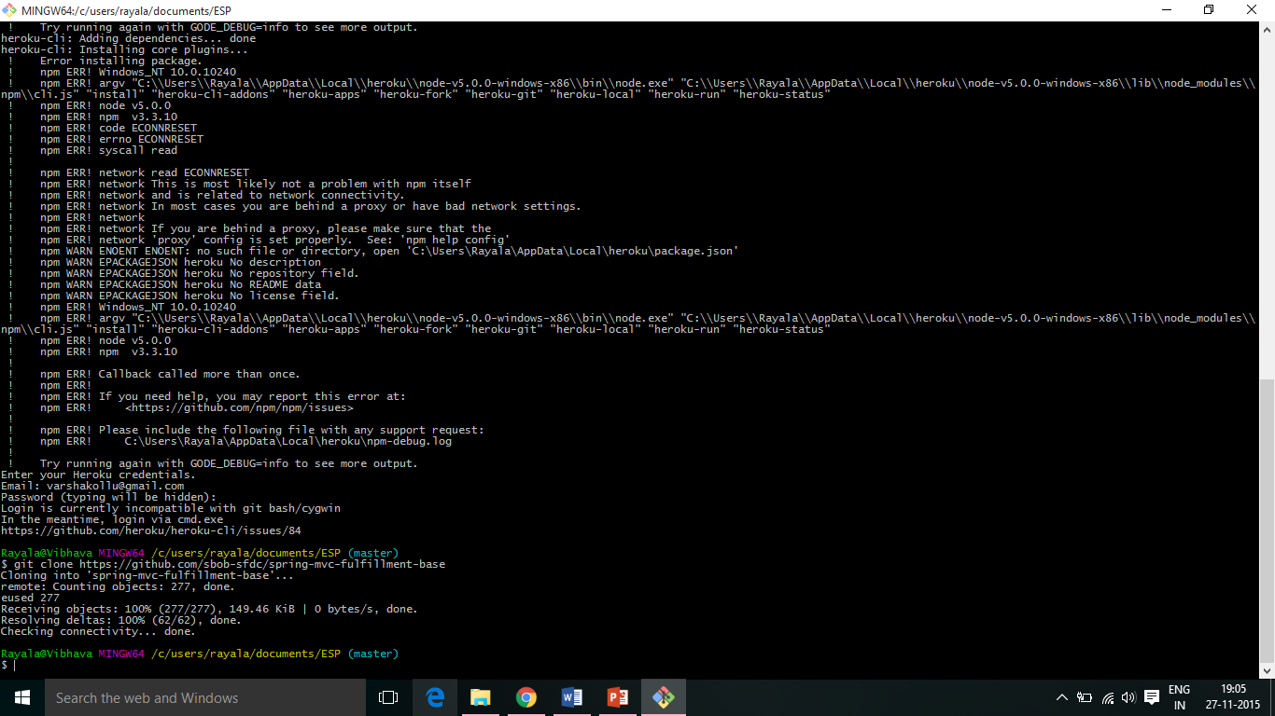

5.2 Change directory to the spring-mvc-fulfillment-base folder you created in the last step and execute the following command cd spring-mvc-fulfillment-base.

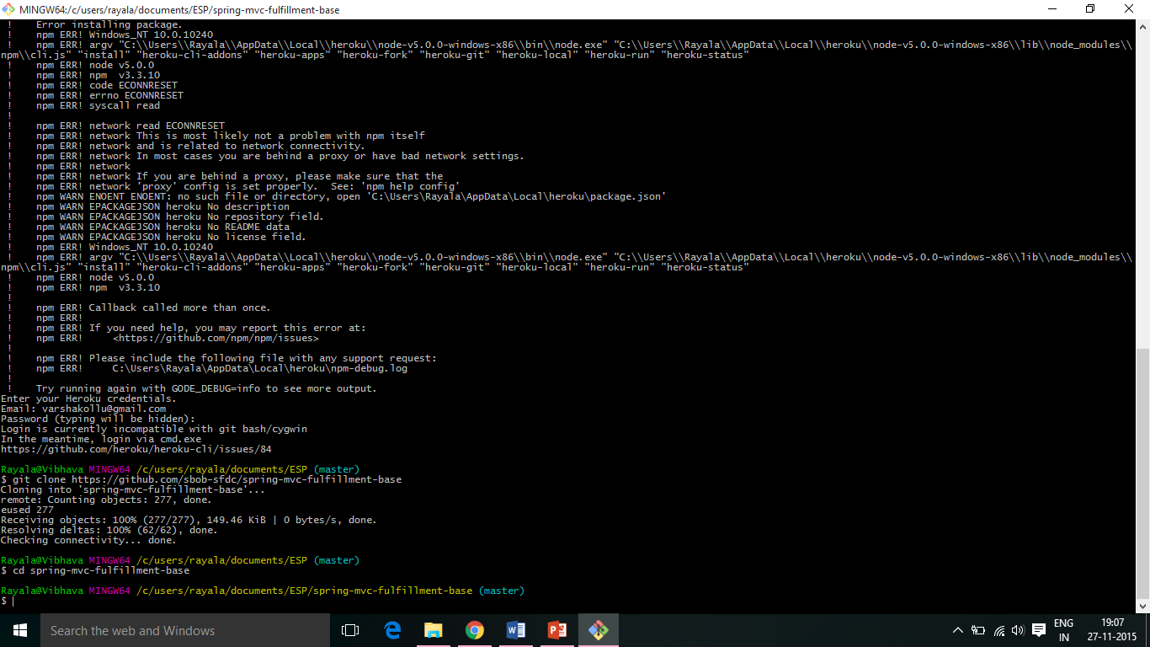

5.3 Login to heroku using the command heroku login.

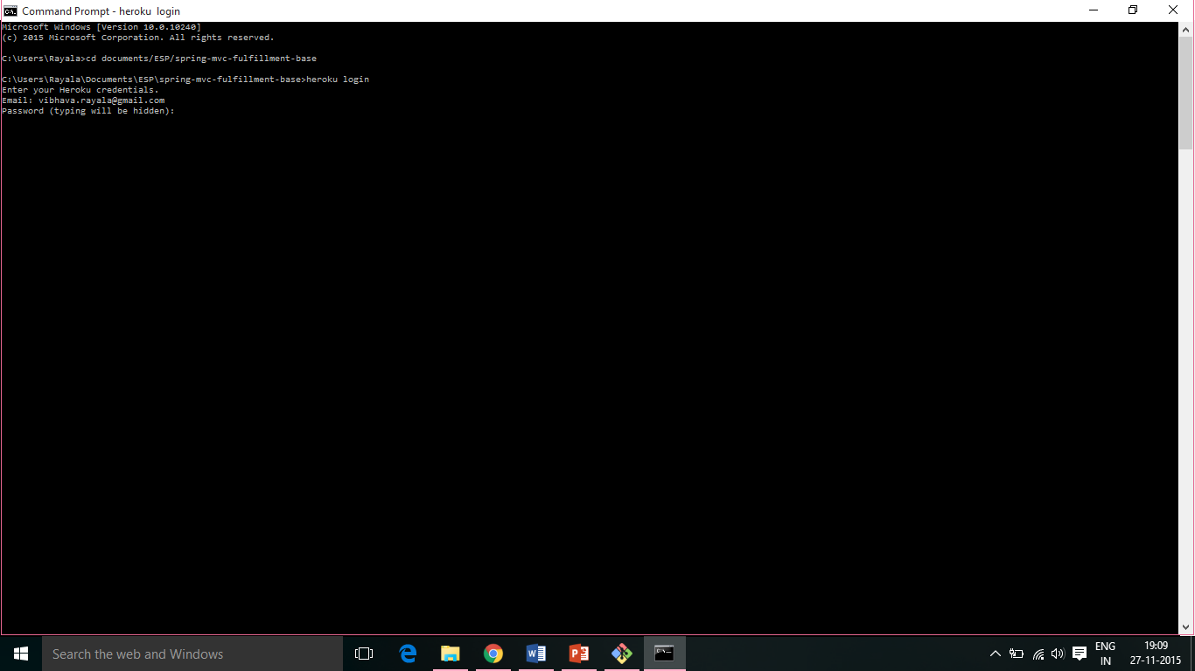

5.4 Enter your login credentials.

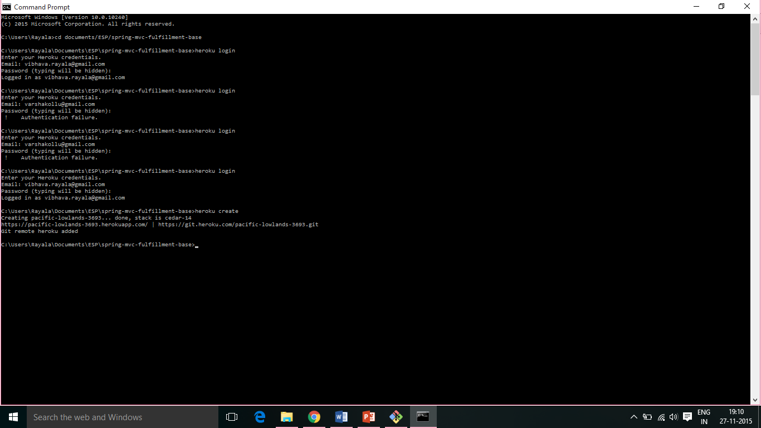

5.5 Execute herokue create to creates a local Git repository as well as a new repository on its hosting framework, where you can push applications, and adds the definition for that remote deployment for your local Git repository to understand.

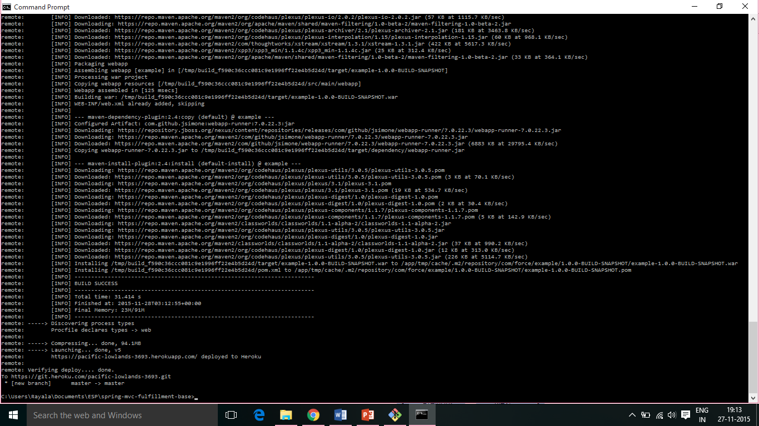

5.6 Execute git push heroku master command.

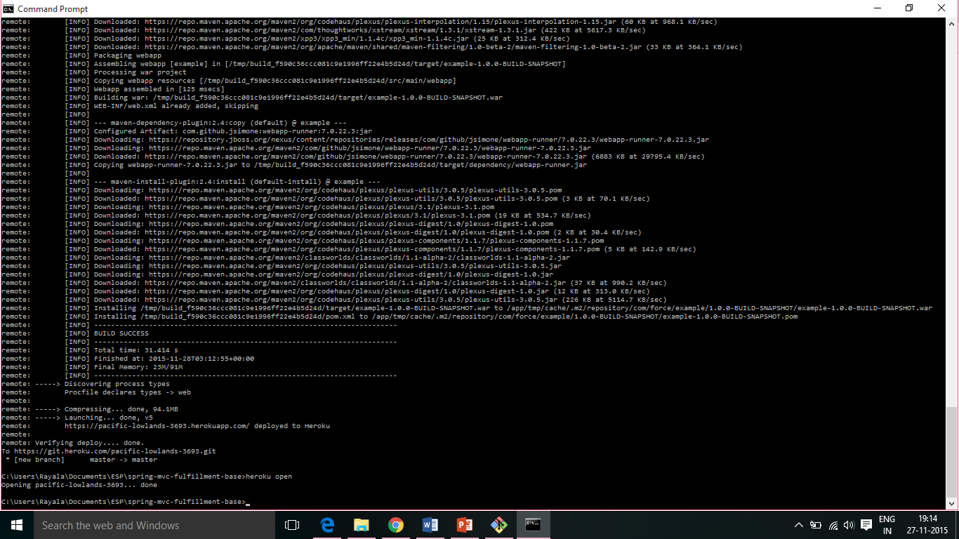

5.7 Execute heroku open command to open the application and click on ajax@controller example.

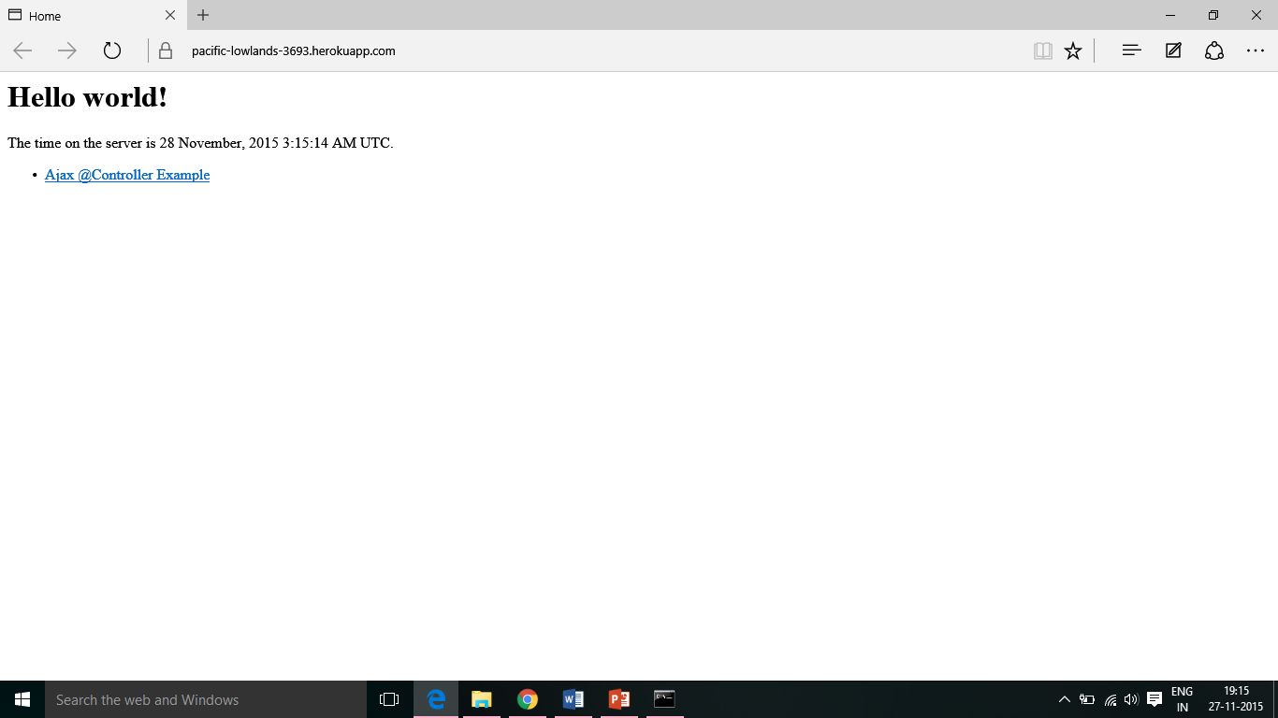

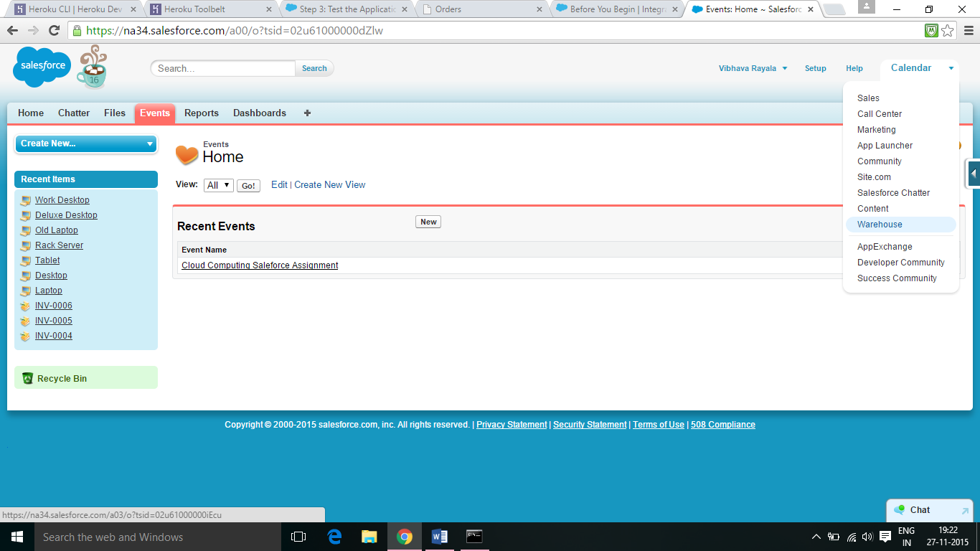

5.8 Open the Warehouse application on your Force.com instance. Click Invoices and then create or select a new invoice. 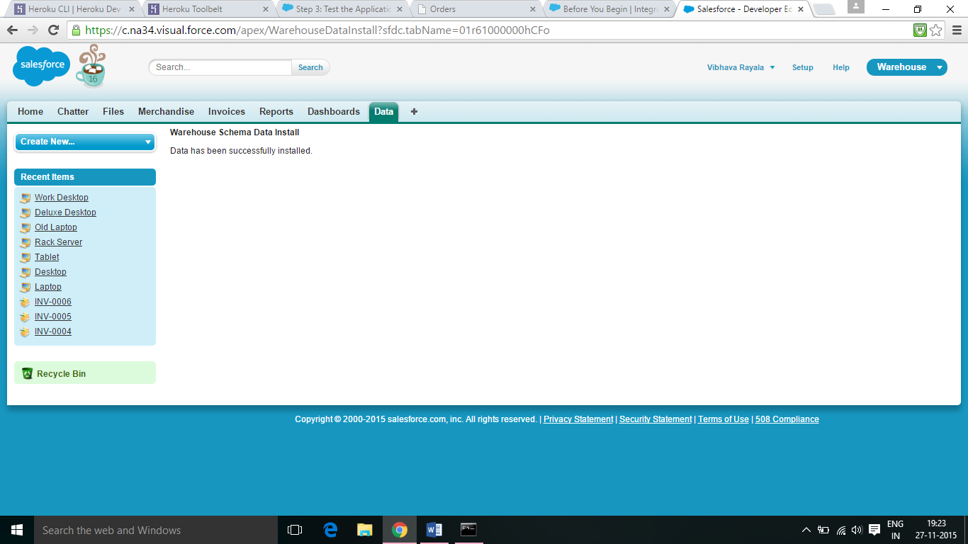

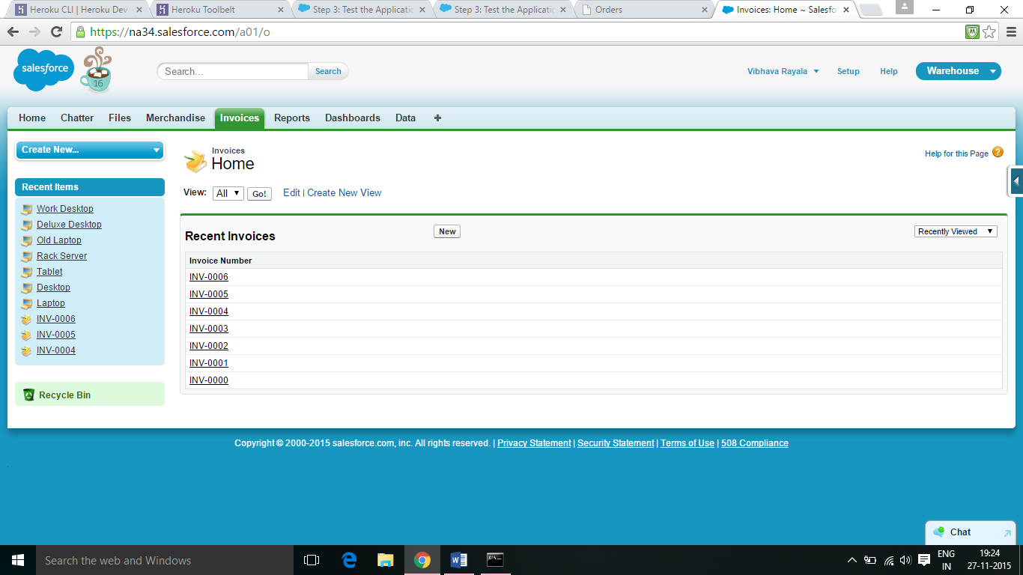

5.9 In the browser URL bar, select the invoice record ID, which is everything after salesforce.com in the URL. It should look something like a01E0000000diKc. Copy the ID to your clipboard.

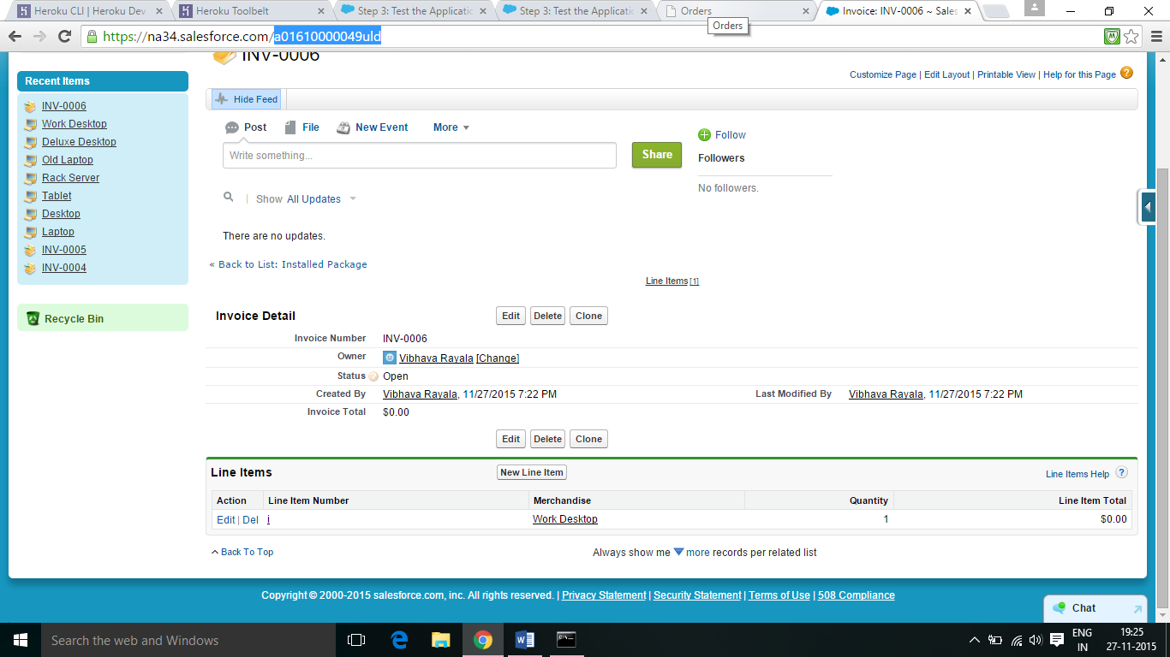

5.10 Open the tab showing your Heroku application and paste the invoice record ID into the field under Id. Click Create.

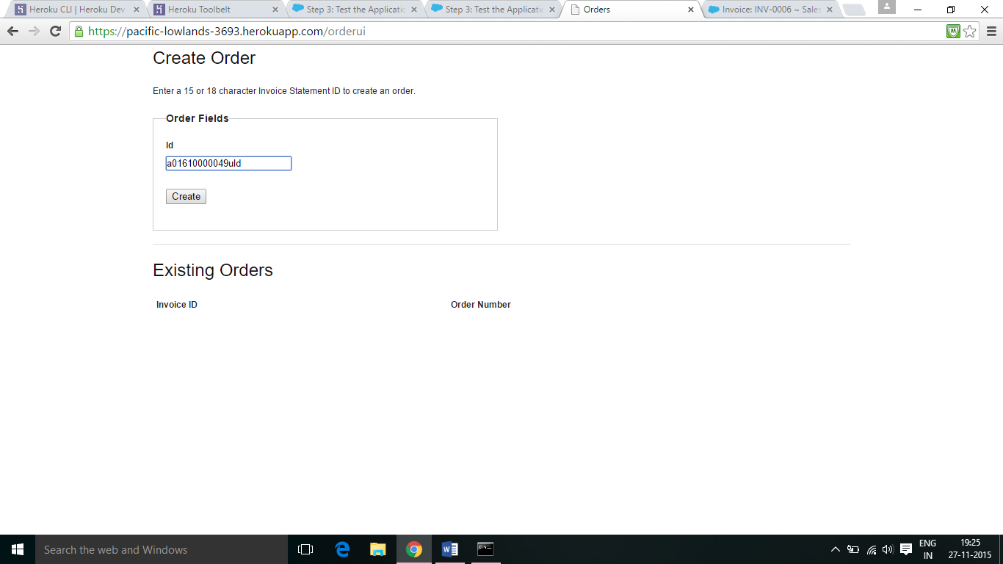

5.11 An order is created with the Invoice ID. Note that this order is distinct from a Salesforce order record.

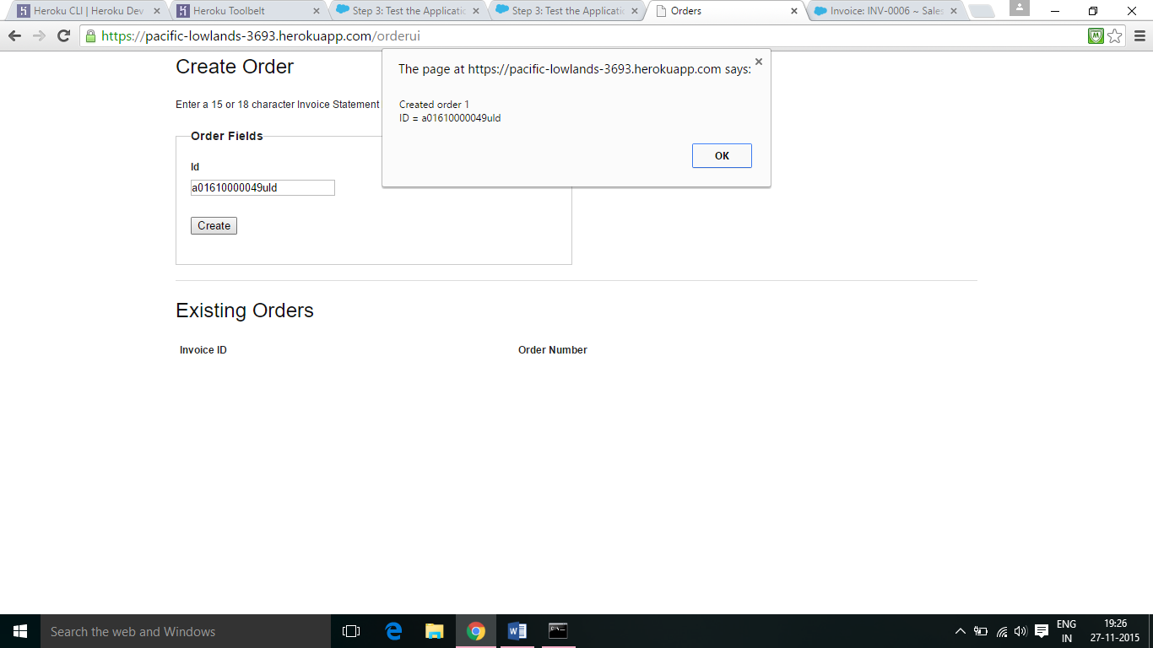

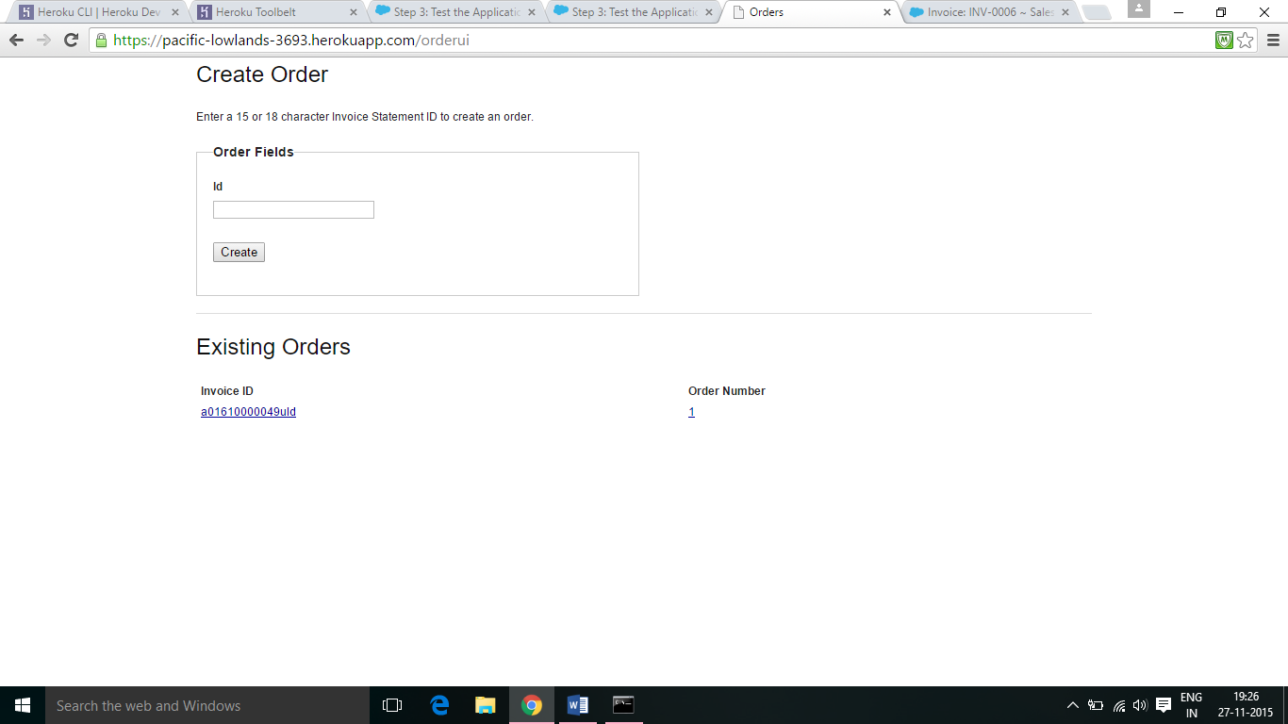

6. Connect the Warehouse App with an External Service:

6.1 Log in to your Salesforce organization. Go to the Invoice Statement custom object from Setup by entering Invoice in the Quick Find box, then selecting Invoice. Scroll down to Custom Fields & Relationships, and then click New.

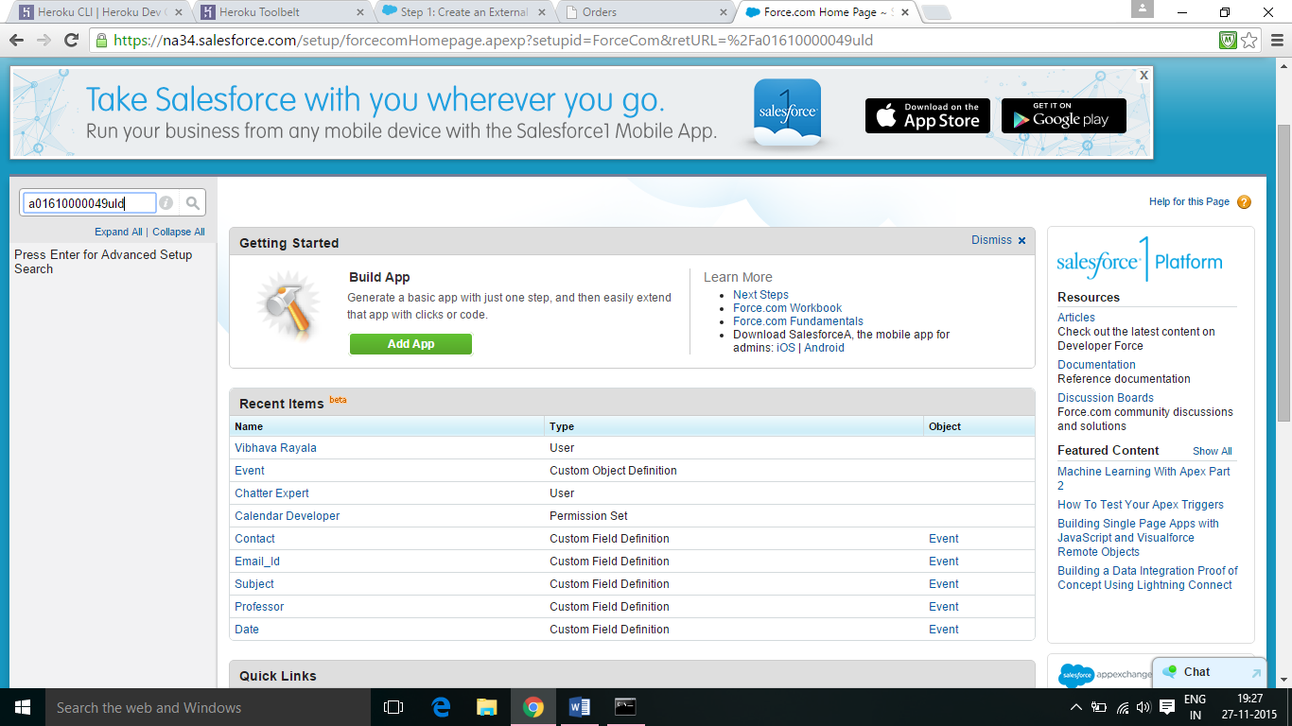

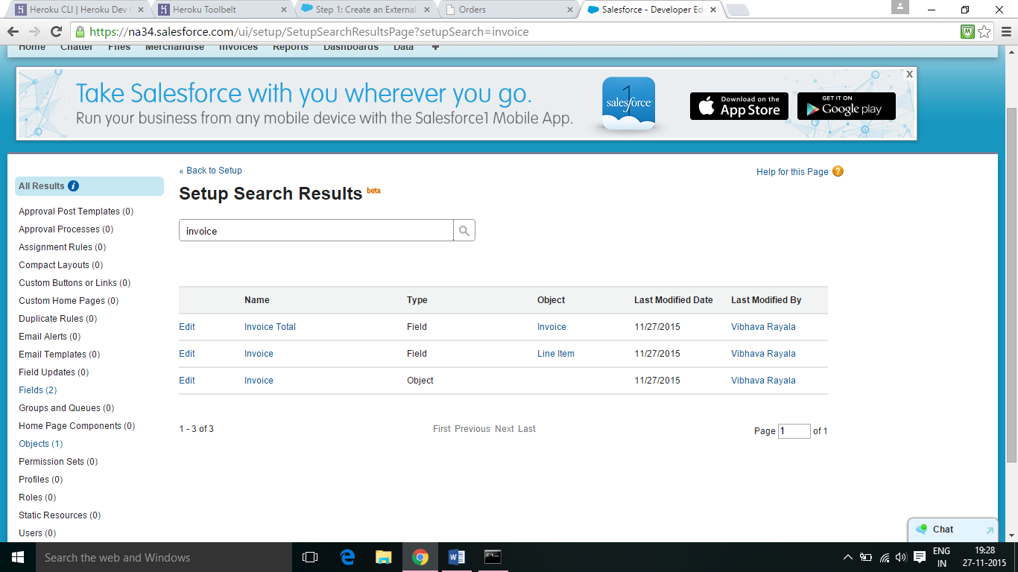

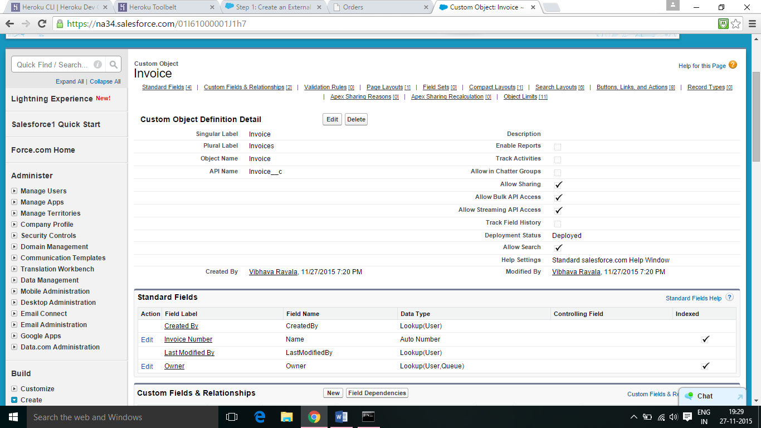

6.2 Select the Text field type, and then click Next. Enter OrderId as the field label, and then enter 6 as the field length. Accept the default field name OrderId. Select the External ID checkbox, and then click Next. Click Next to accept the defaults, and then click Save.

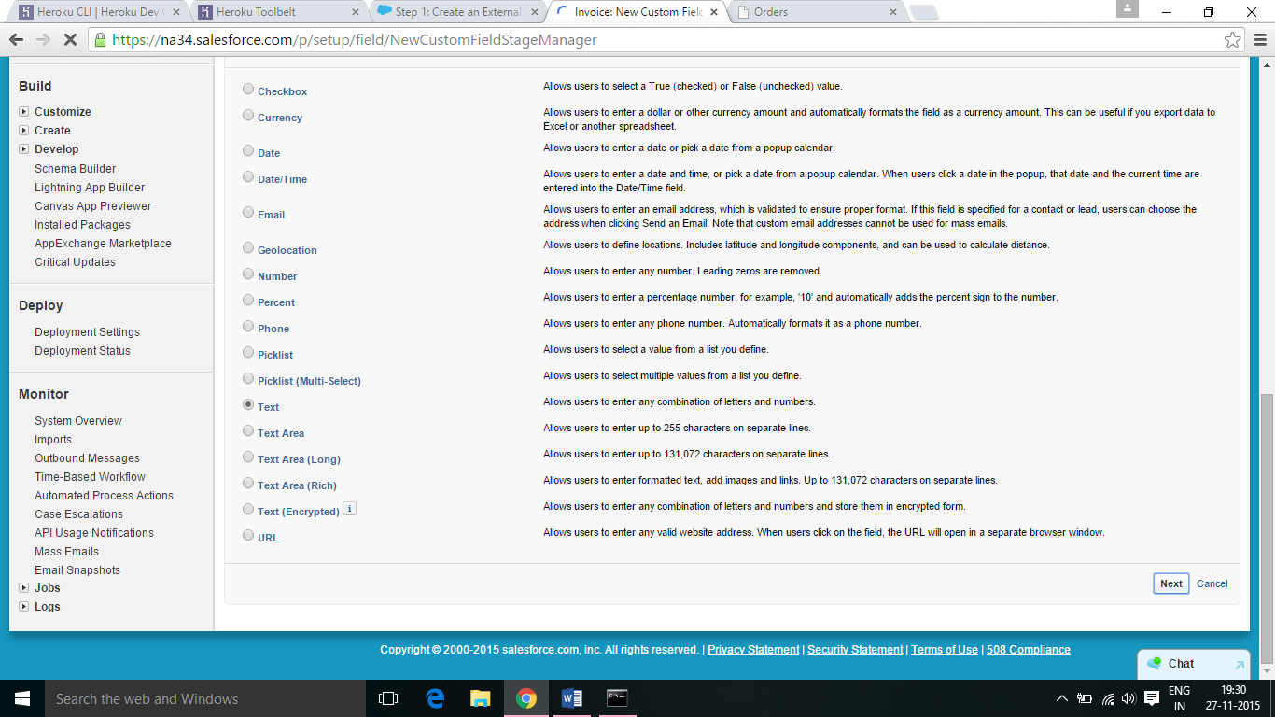

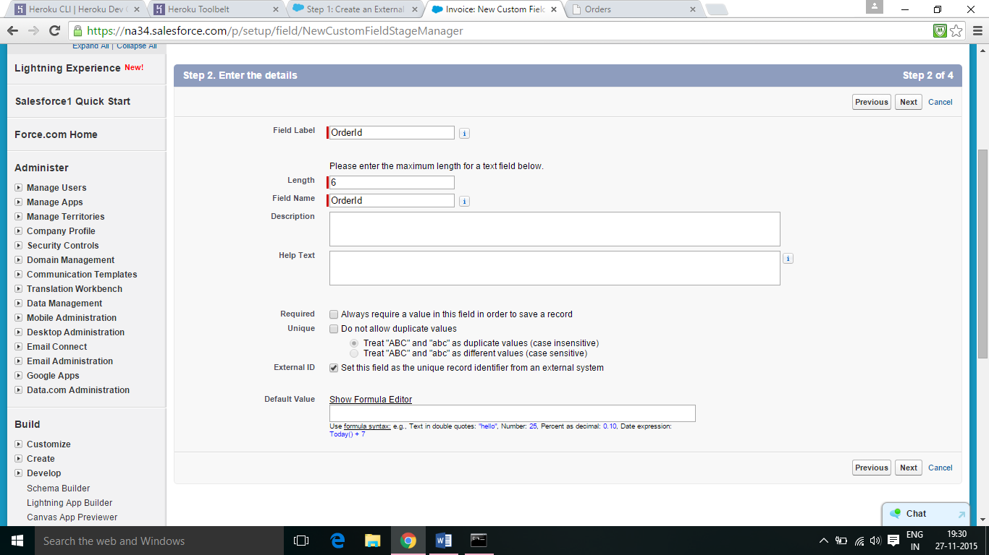

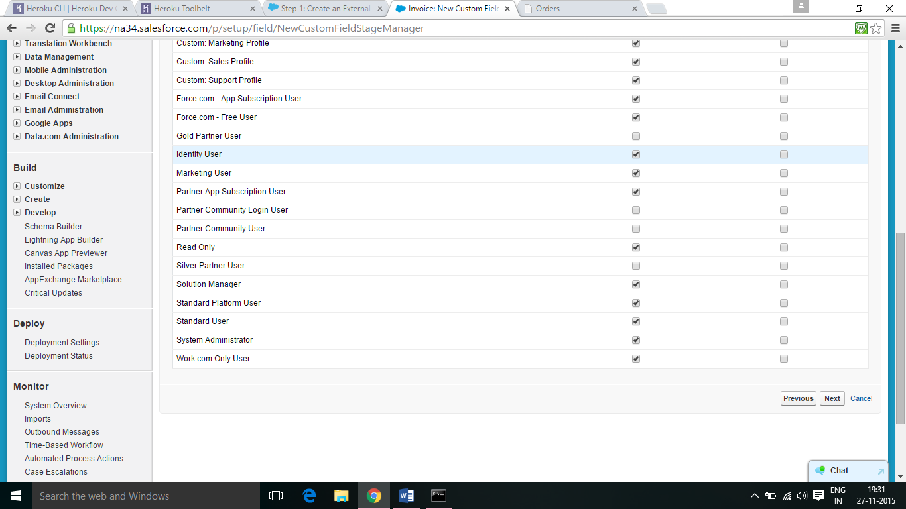

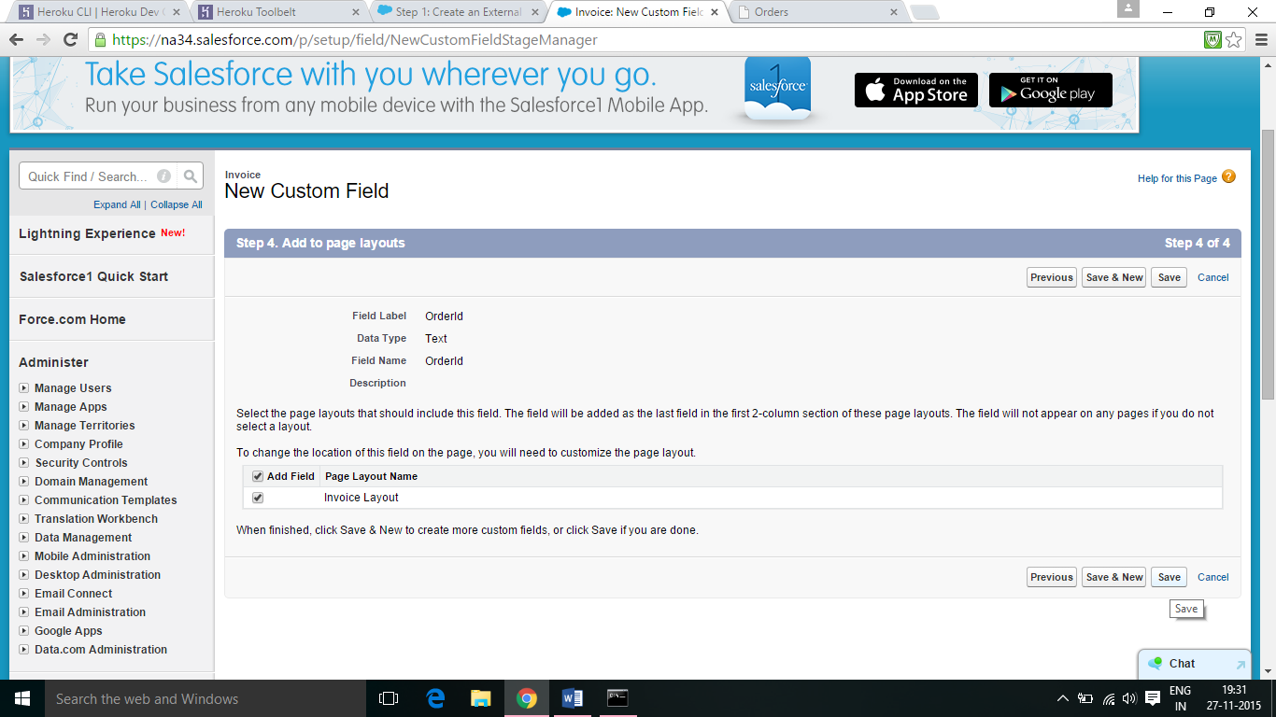

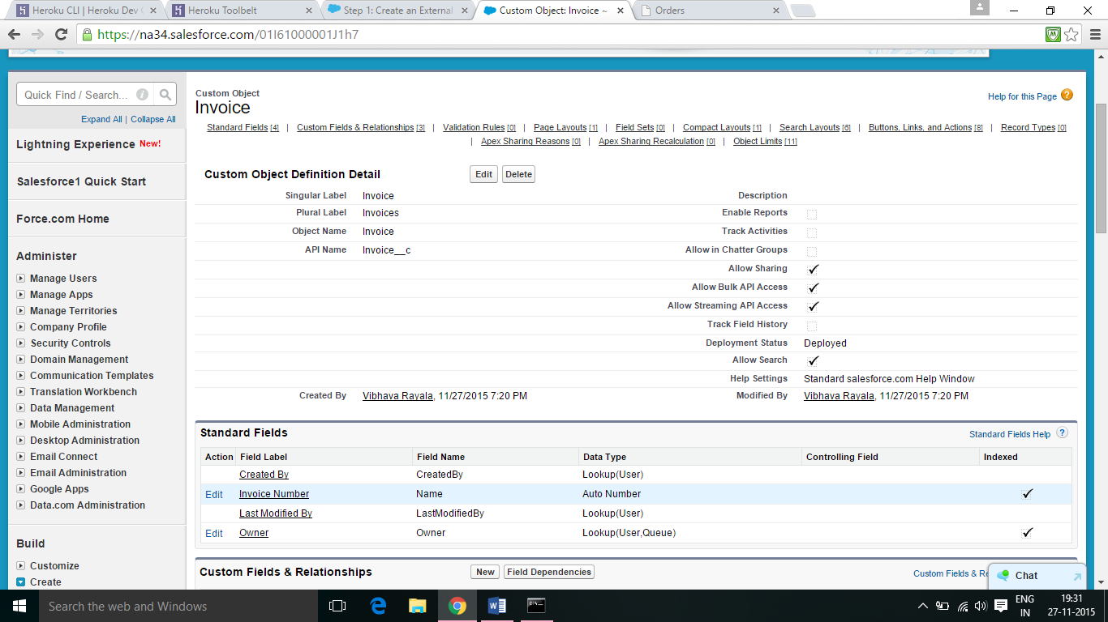

6.3 Select the Text field type, and then click Next. Enter OrderId as the field label, and then enter 6 as the field length. Accept the default field name OrderId. Select the External ID checkbox, and then click Next. Click Next to accept the defaults, and then click Save.

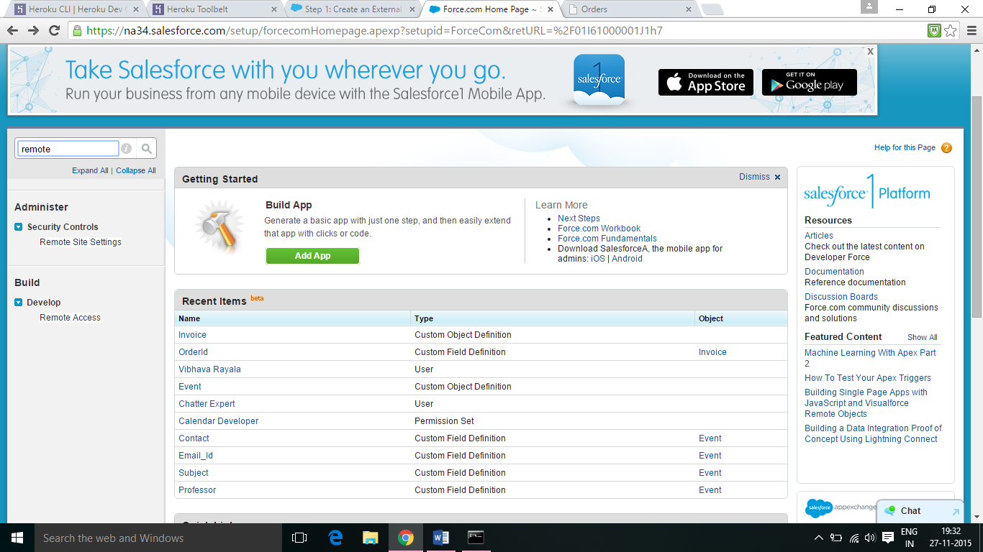

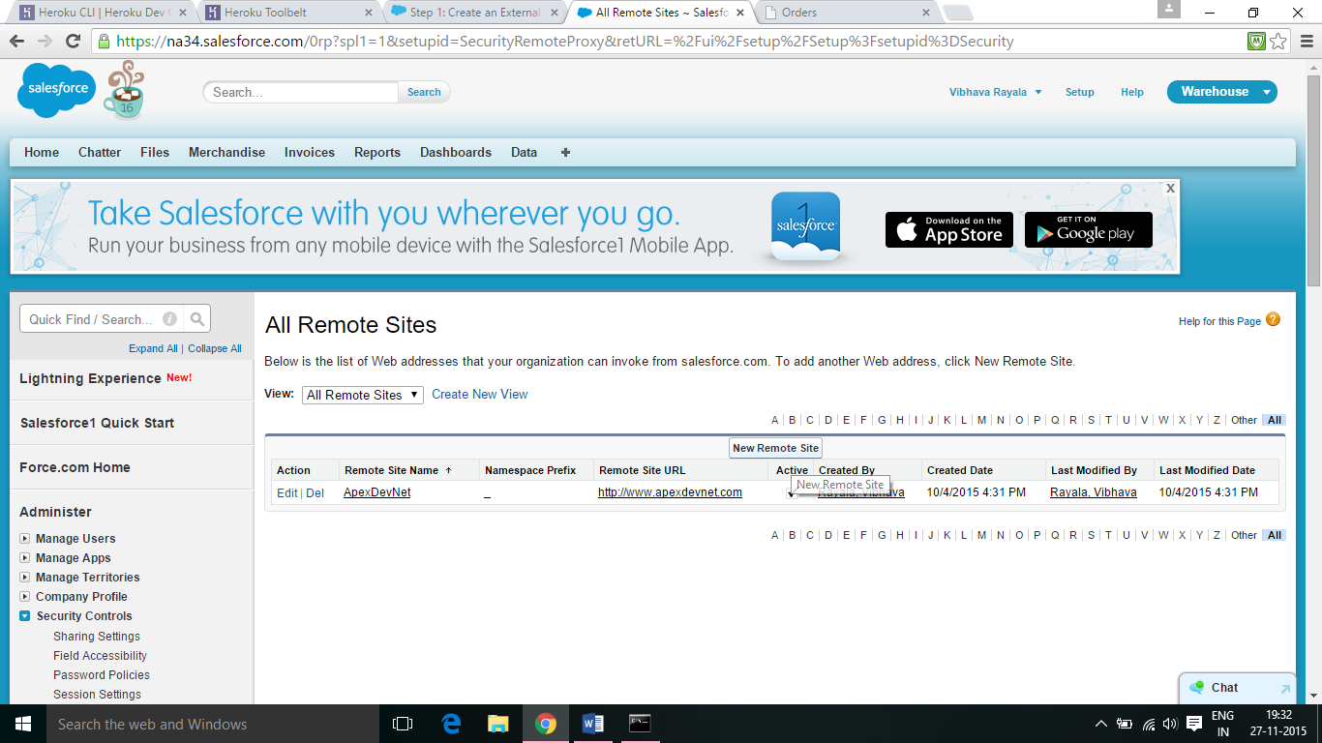

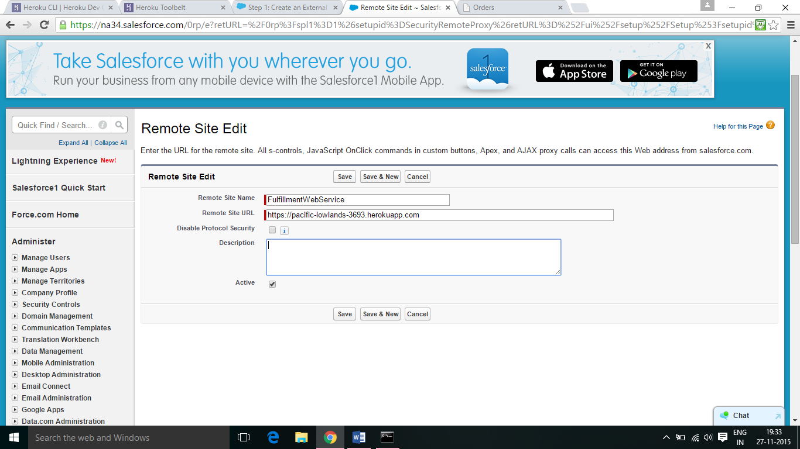

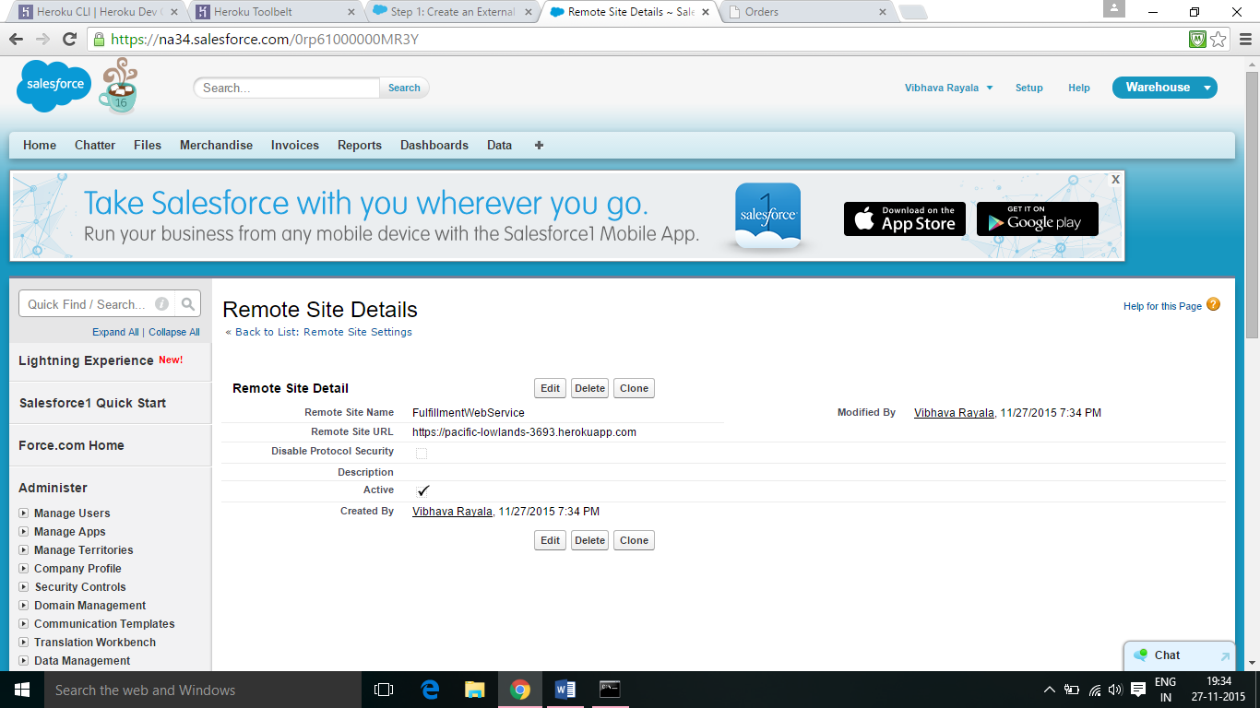

6.4 From Setup, enter “Apex Classes” in the Quick Find box, then select Apex Classes. Click New and paste in the code and click save.

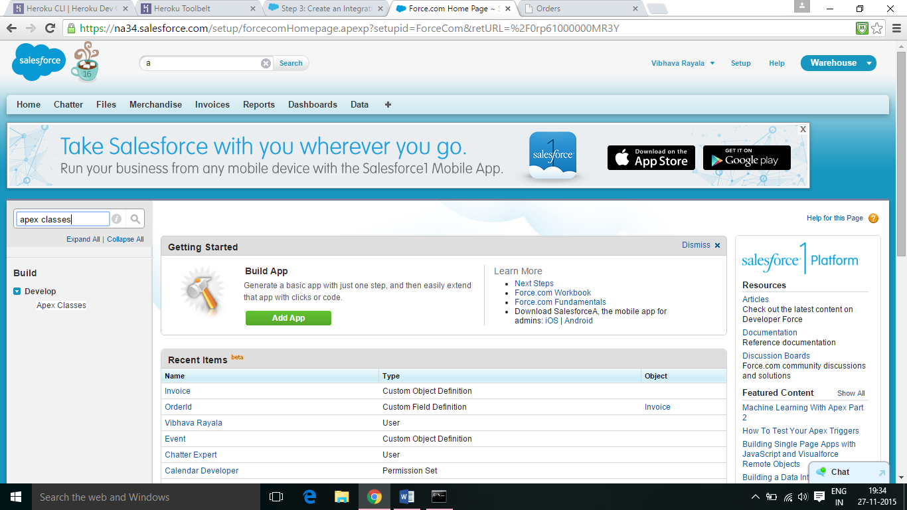

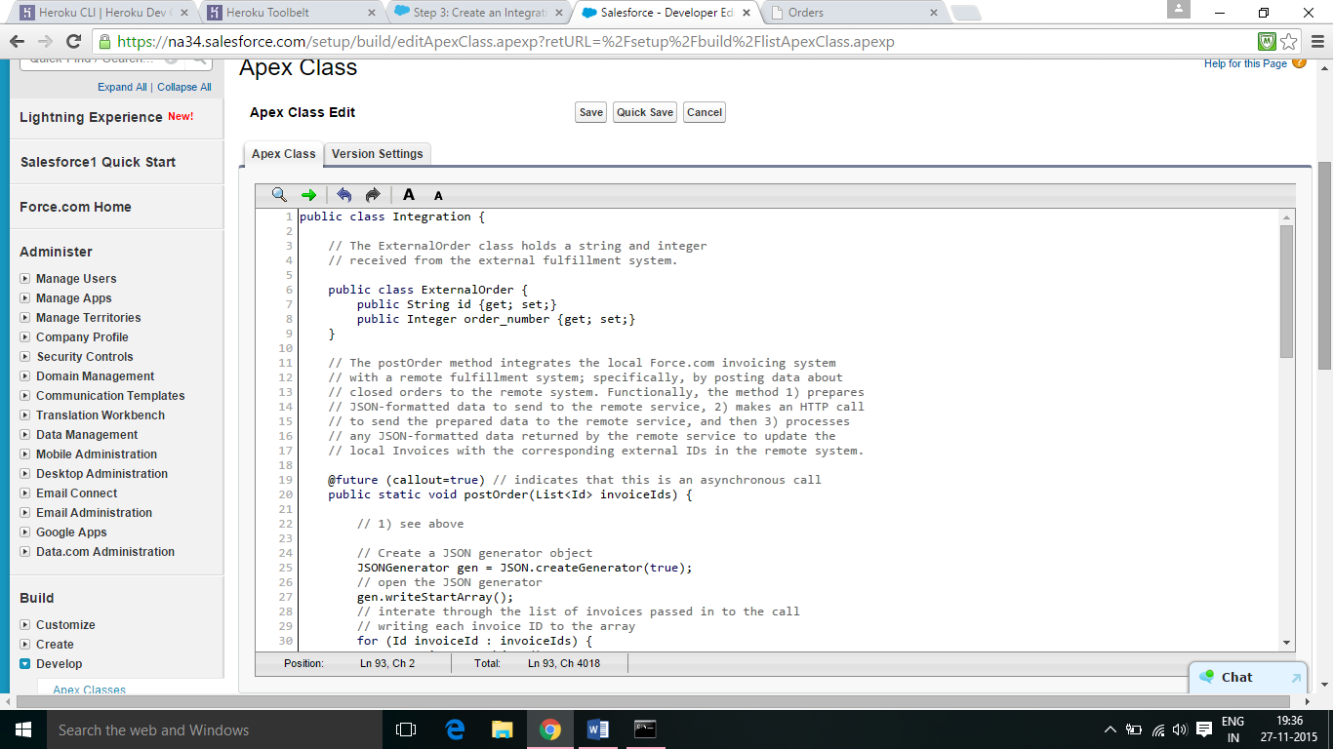

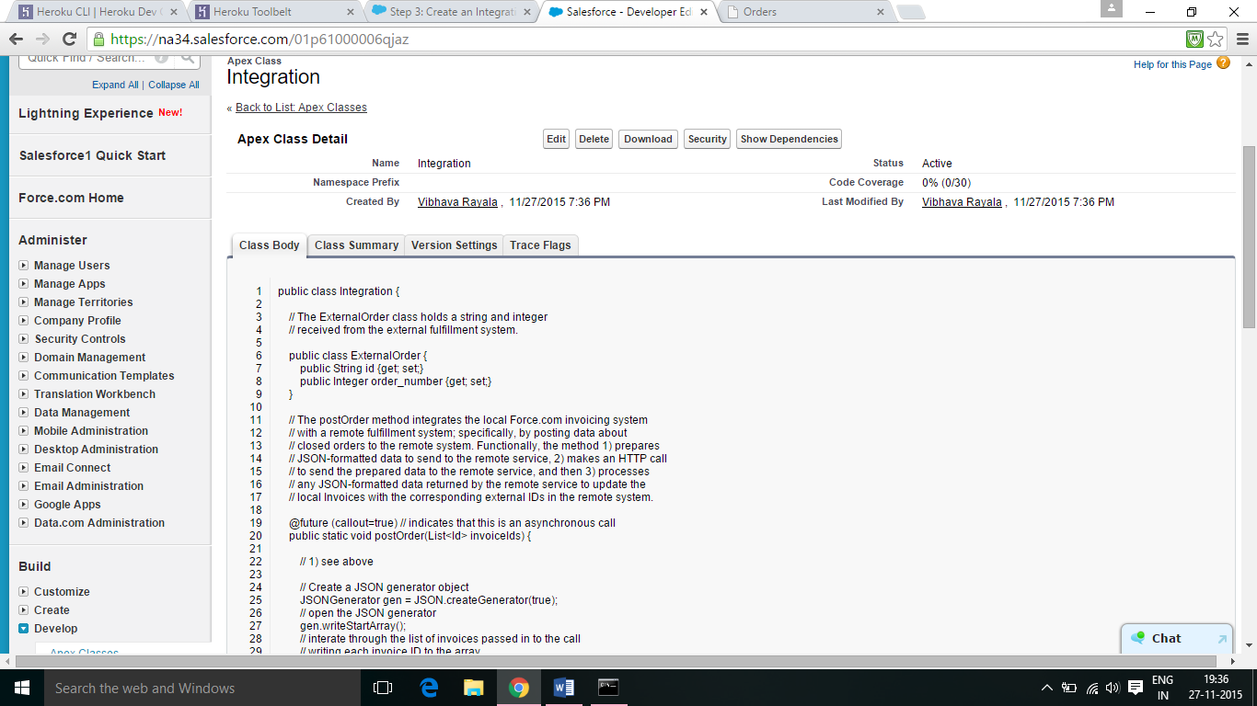

6.5 Open the Developer Console. Click Debug | Open Execute Anonymous Window, and then enter the following code:

// Get an Invoice__c for testing

Invoice__c invoice = [SELECT ID FROM Invoice__c LIMIT 1];

// Call the postOrder method to test the asynchronous call

Integration.postOrder(new List<Id>{invoice.id});

Select the Open Log checkbox. Click Execute. You should see two entries in the logs at the bottom of the page. Double click the second line.

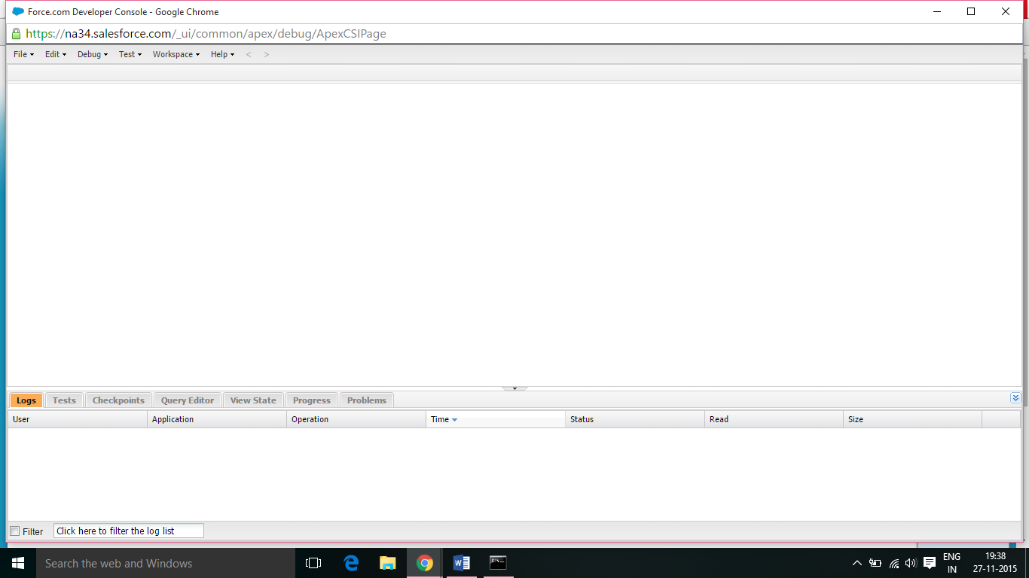

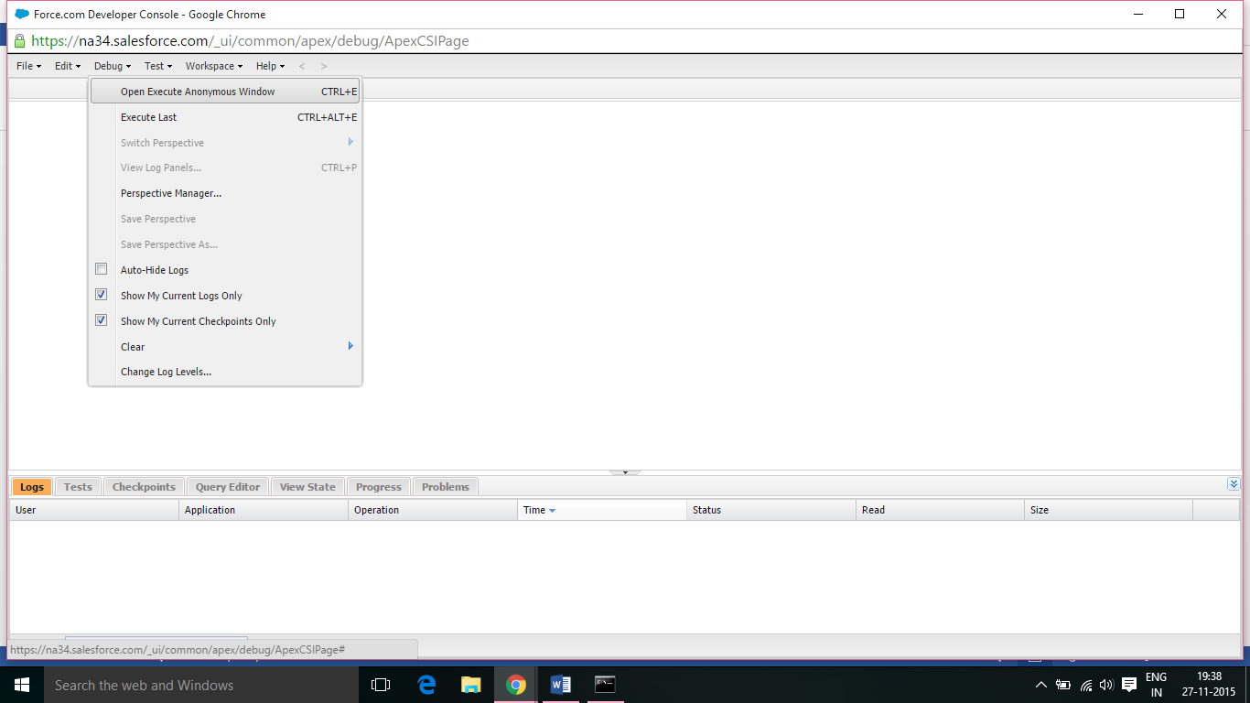

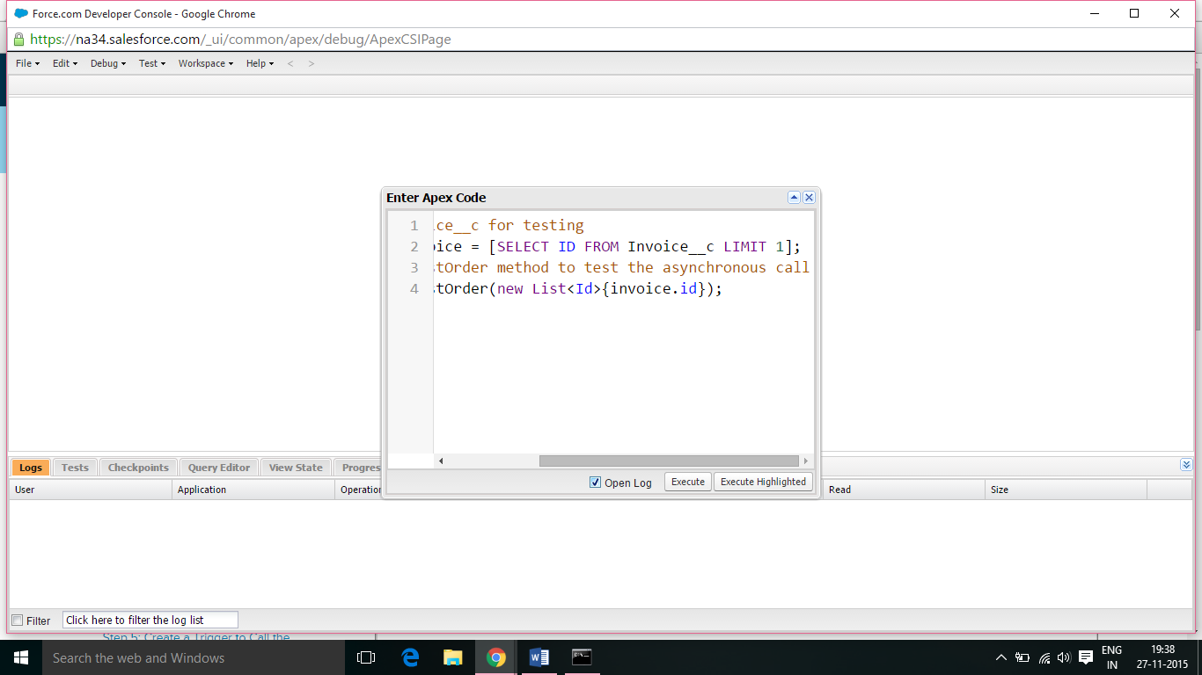

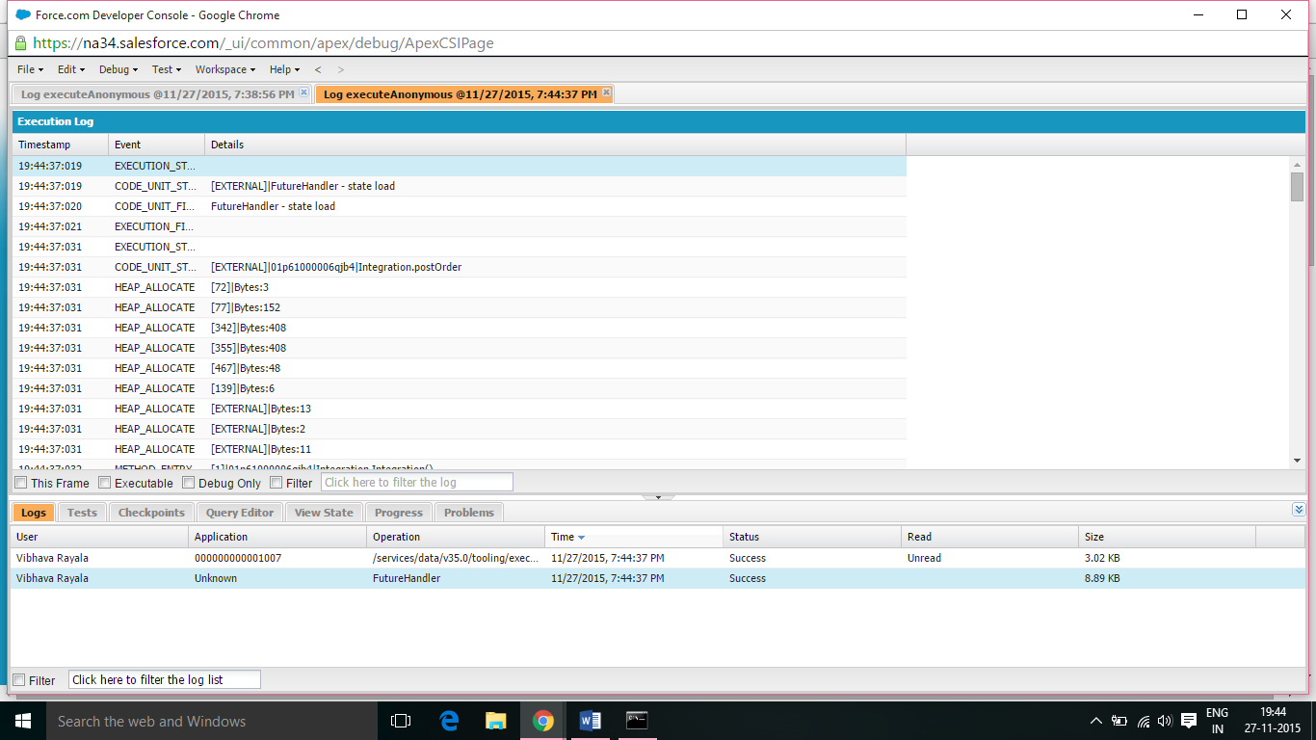

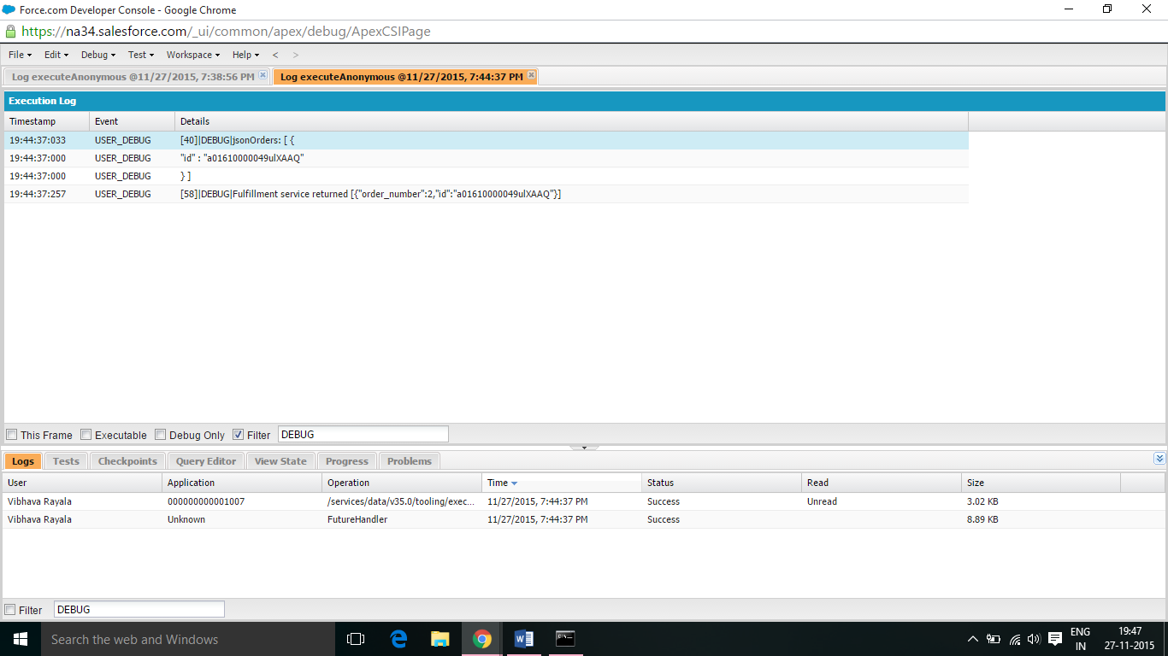

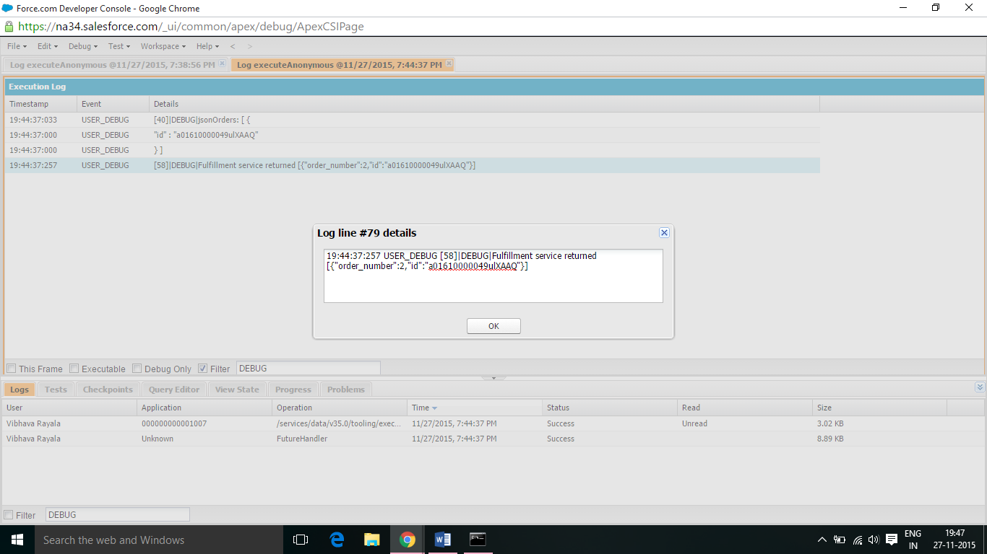

6.6 Go to the invoice custom object from Setup by entering Invoice in the Quick Find box, then selecting Invoice. Scroll down to Triggers, click New and then paste the code.

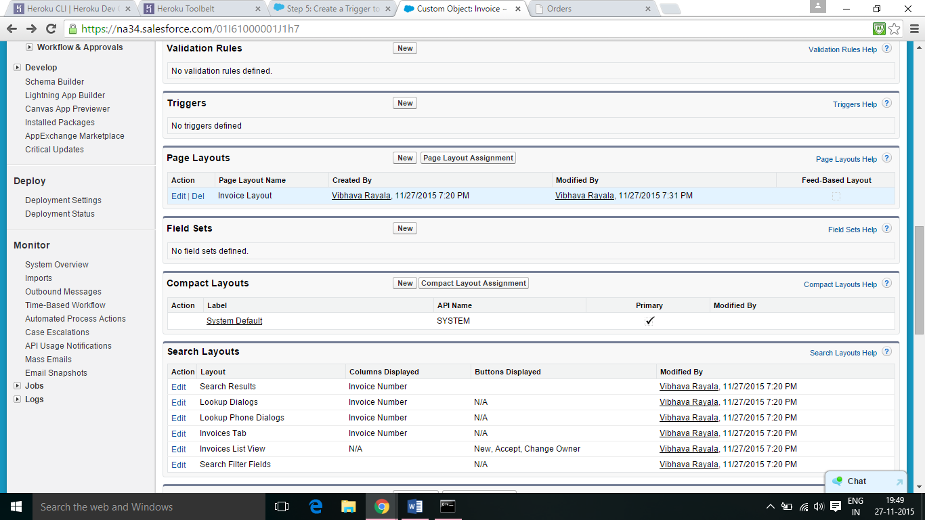

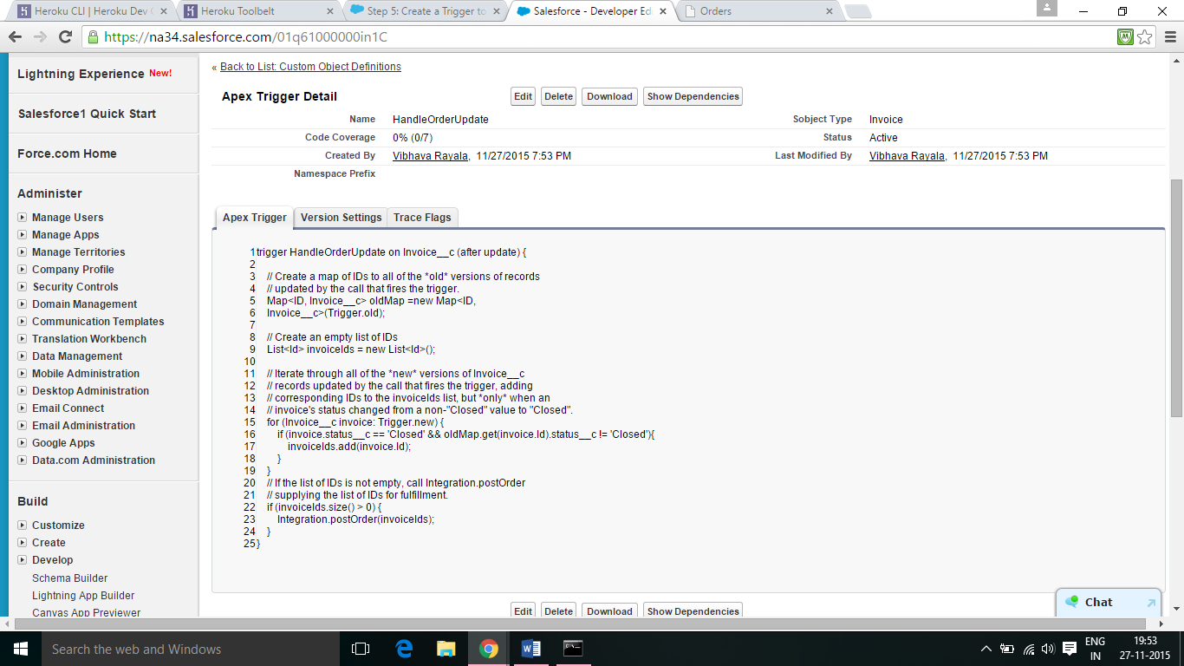

6.7 Select the Warehouse app. Click the Invoices tab. Click one of the recent invoices and notice that there is no OrderId for the invoice. If the Status is already Closed, double-click the word Closed, change it to Open and click Save. Double-click the Status value, change it to Closed and click Save. This triggers the asynchronous callout. Wait a few seconds and refresh the page in the browser. You should see an external order ID appear in the OrderId field.

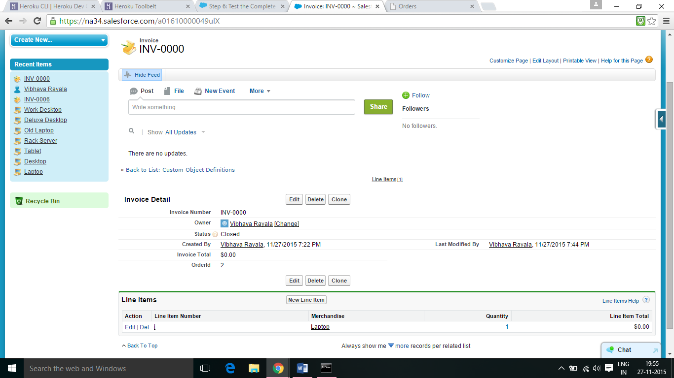

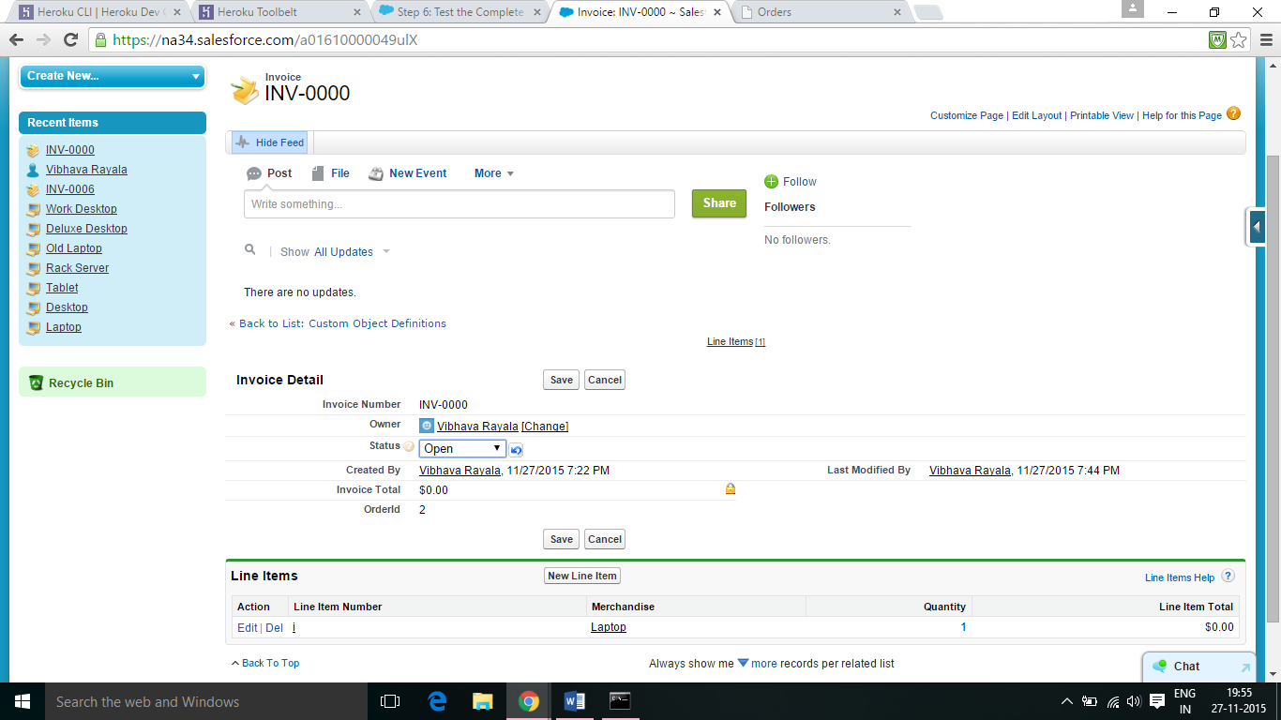

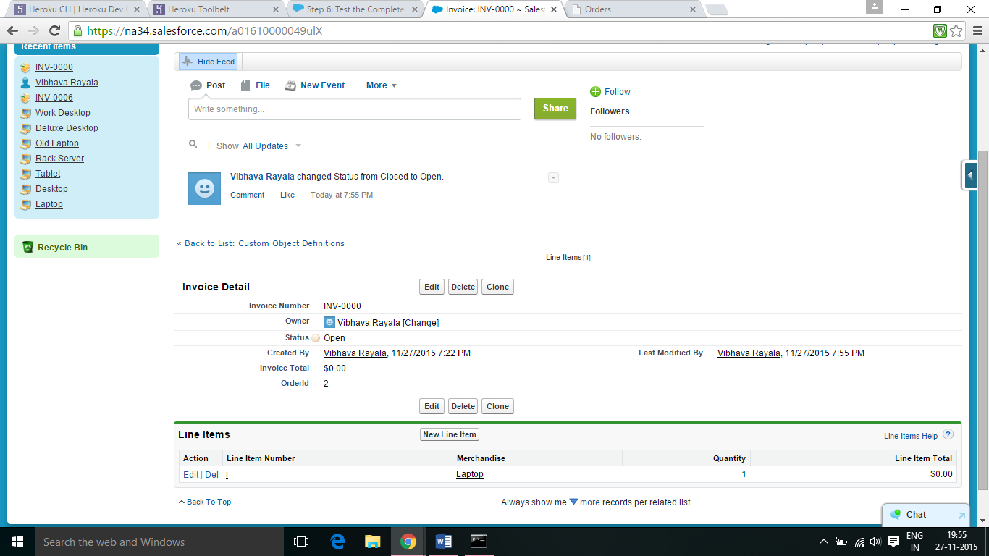

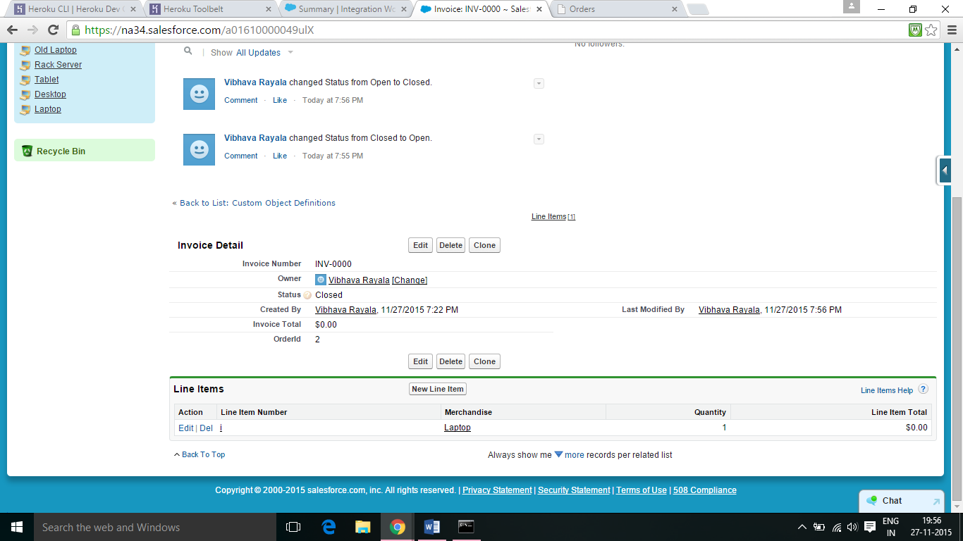

7. UPDATE THE HEROKU APP:

7.1 From Setup, enter Apps in the Quick Find box, then select Apps. In the Connected Apps section, click New. For Connected App Name, enter your app name. Enter the API Name, used when referring to your app from a program. It defaults to a version of the name without spaces. Provide your Contact Email. Under API (Enable OAuth Settings) select Enable OAuth Settings. For Callback URL, enter https://{appname}.herokuapp.com/_auth. In the Selected OAuth Scopes field, select Full access (full) and Perform requests on your behalf at any time (refresh_token, offline_access), and then add them to the selected OAuth scopes. Click Save.

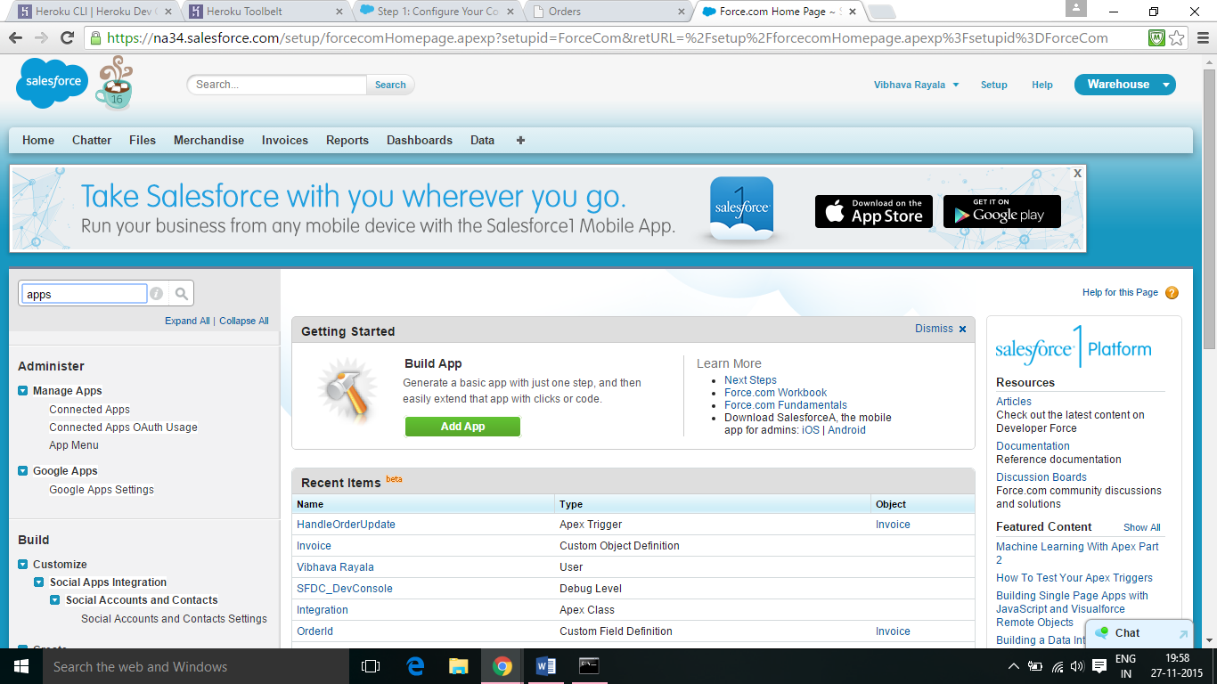

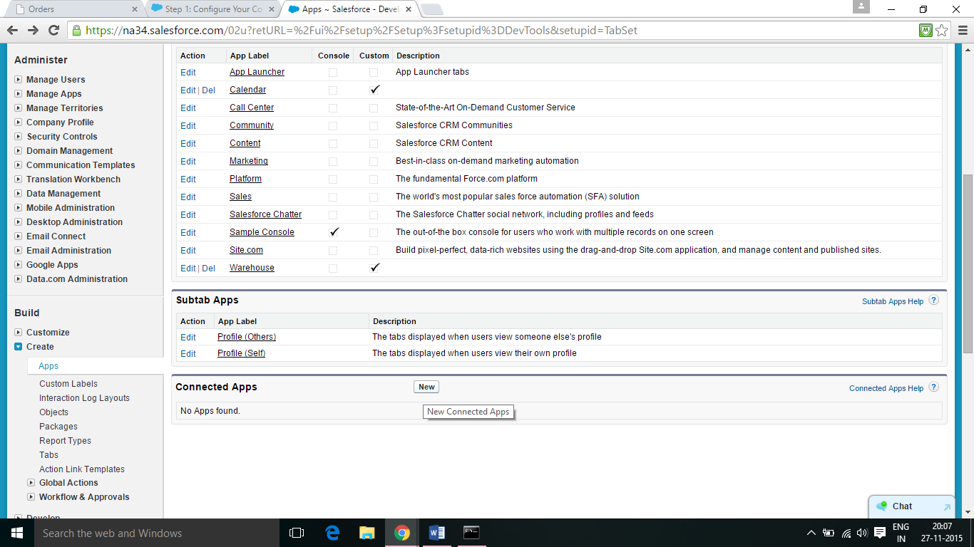

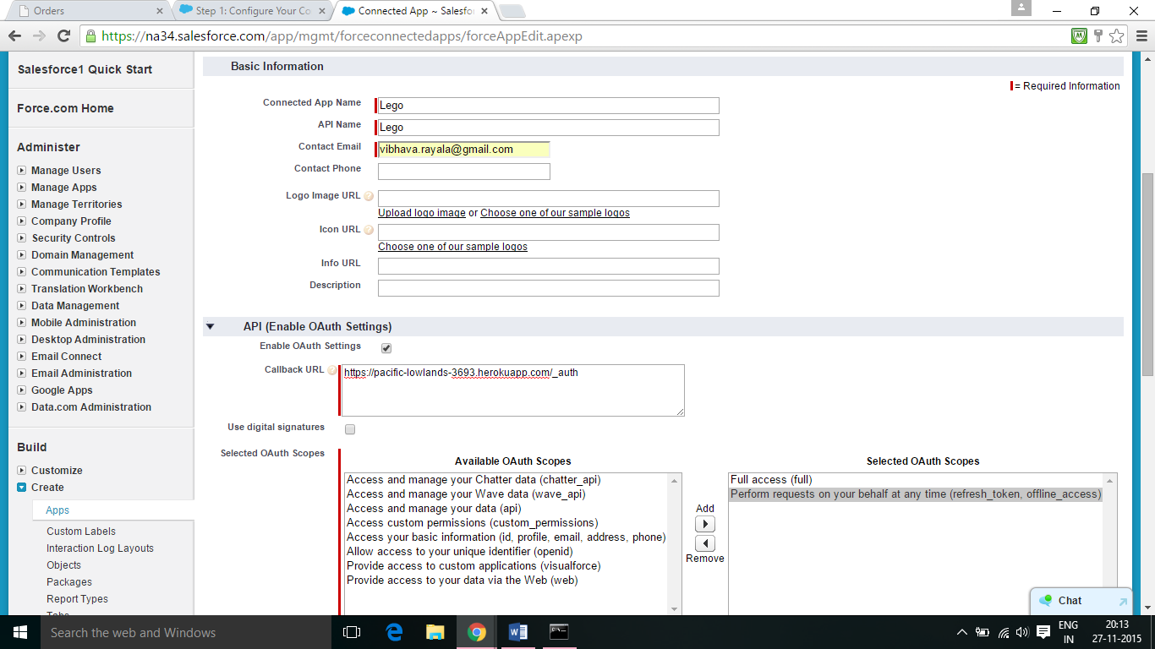

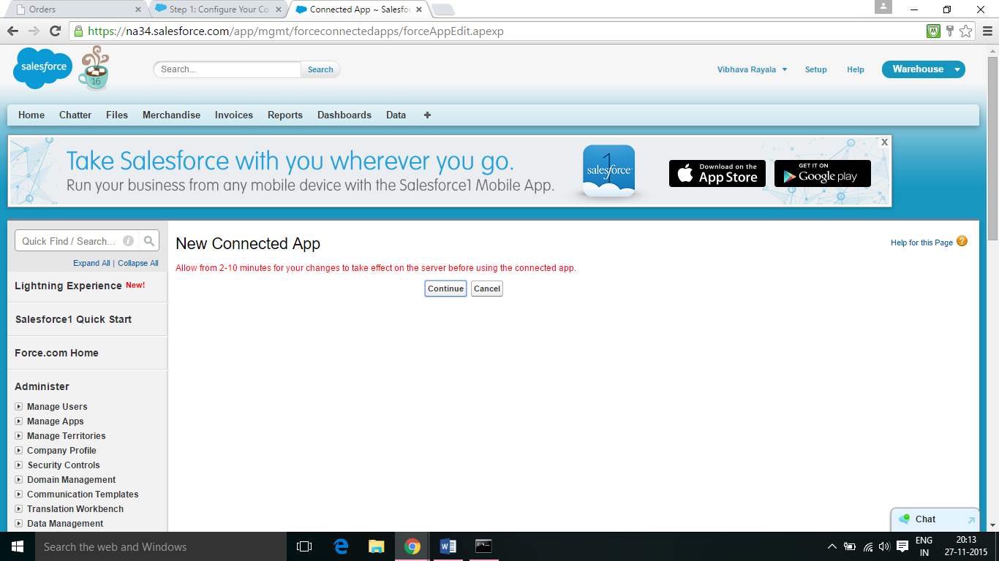

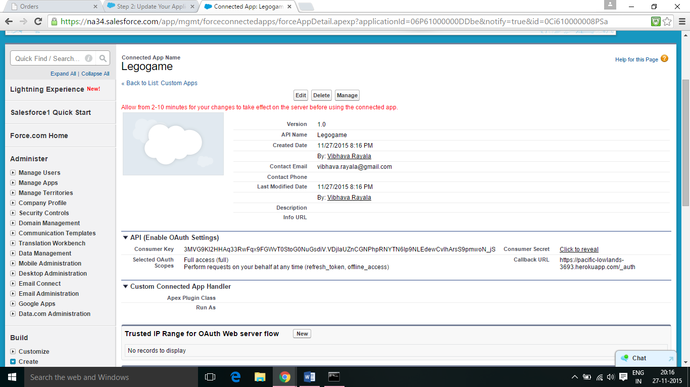

7.2 Return to the command line, and make sure you’re in the spring-mvc-fulfillment-base folder. Enter the following command to fetch the “full” branch and merge it with your master branch, all in one step: git pull origin full. Set your Access keys to your Heroku application using heroku config:add OAUTH_CLIENT_KEY=PUBLICKEY OAUTH_CLIENT_SECRET=PRIVATEKEY. Execute git push heroku master.

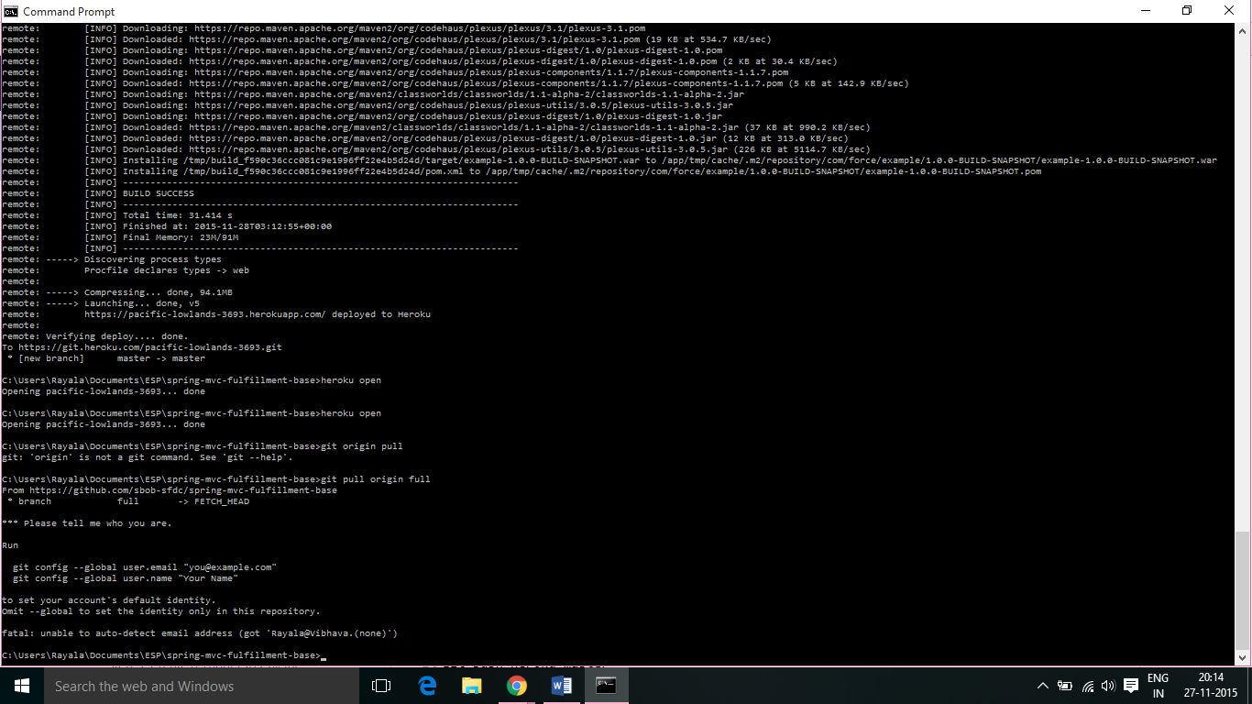

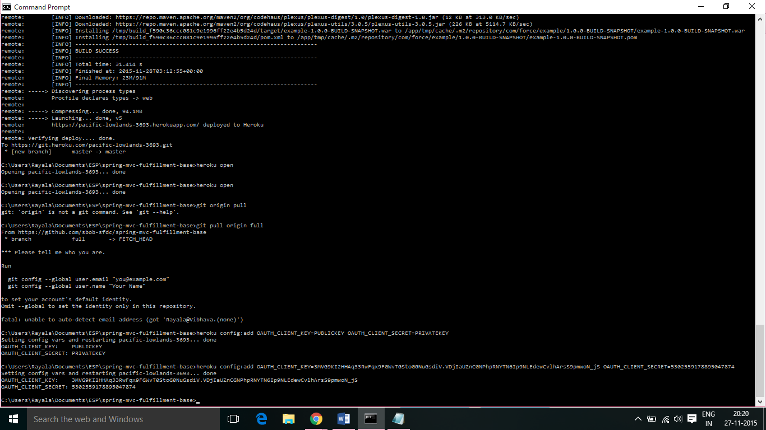

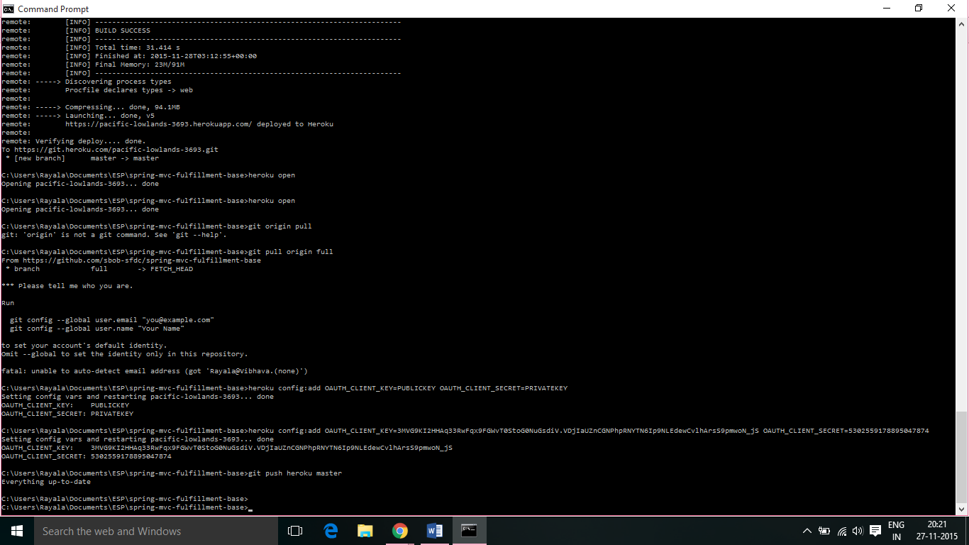

7.3 Navigate to your fulfillment app in the browser, and then refresh the page. Click an order.

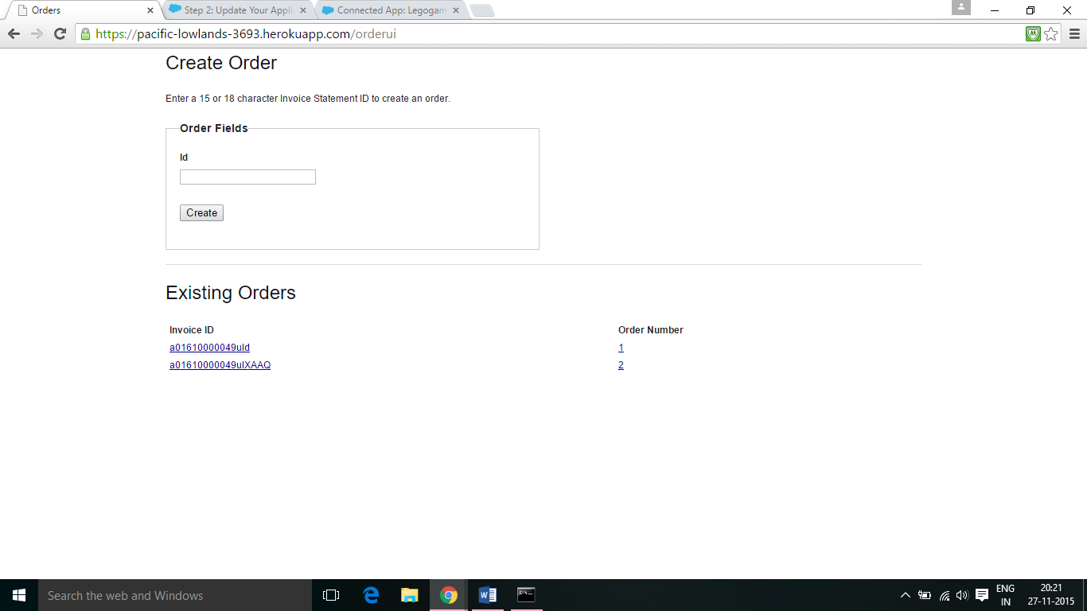

8. Add Your App to Salesforce Using Force.com Canvas:

8.1 Return to the command line, and make sure you’re in the spring-mvc-fulfillment-base folder. Enter the following command to fetch the canvas branch and merge it with your master branch using git pull origin canvas.Execute the following command to push the local changes to Heroku: git push heroku master. In a browser tab or window, navigate to https://{appname}.herokuapp.com to see the changes (refresh your browser if needed).

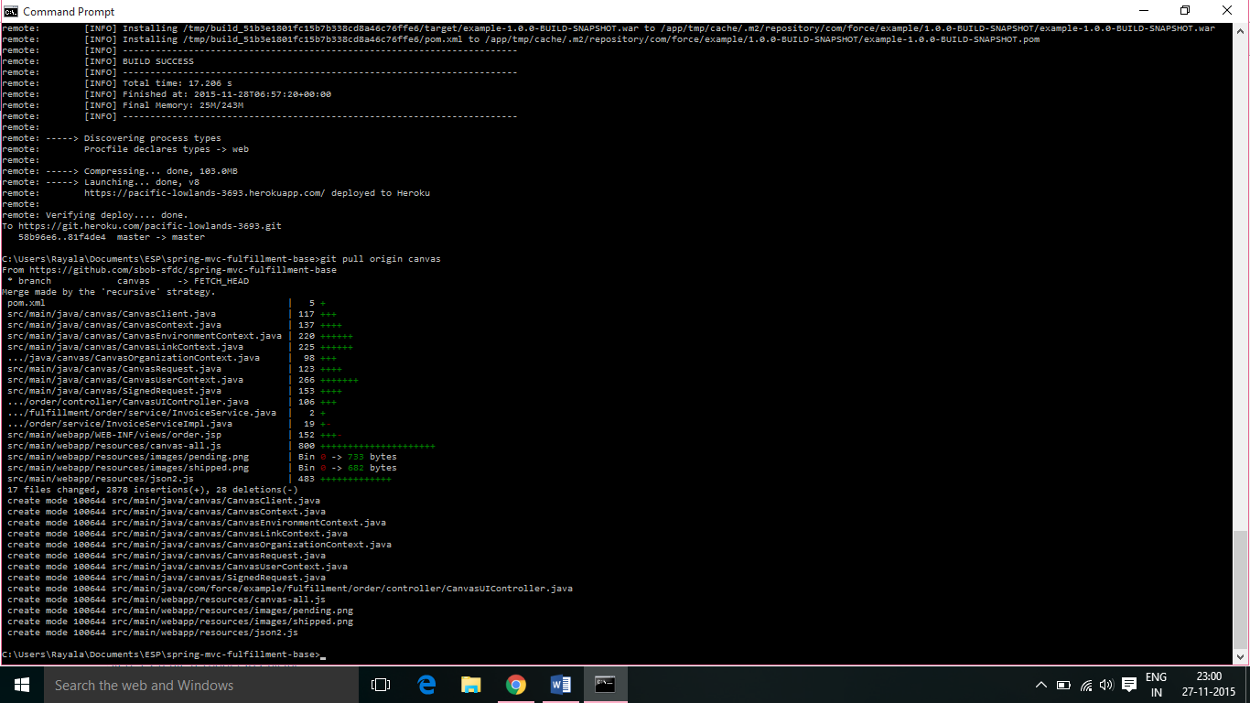

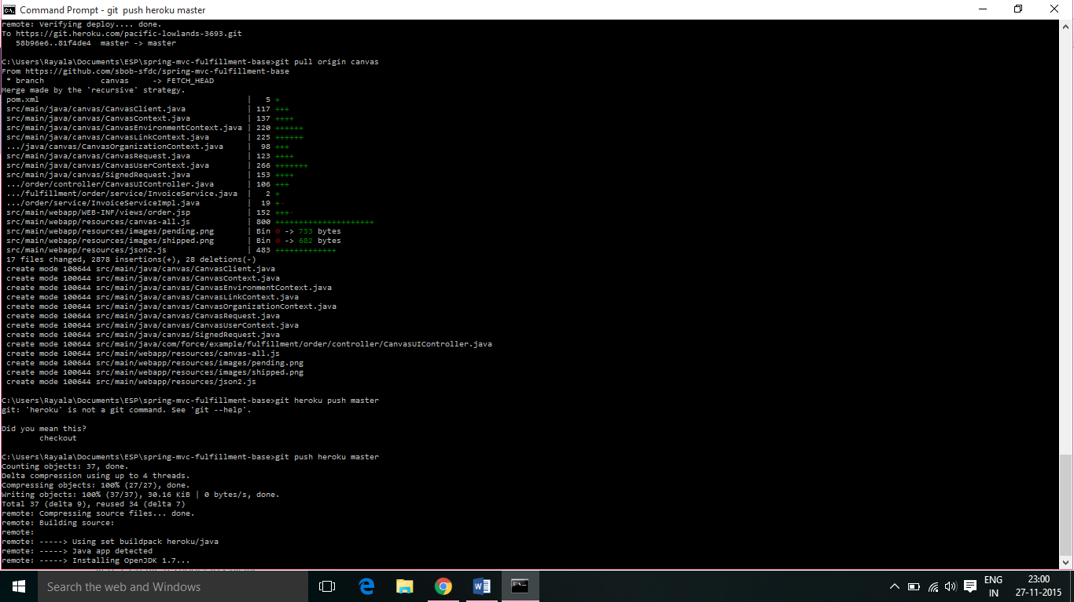

8.2 From Setup, enter Apps in the Quick Find box, then select Apps. In the Connected App Settings section, select your application and click Edit. In the Canvas App Settings section, select the Force.com Canvas checkbox. In the Canvas App URL field, enter https://{appname}.herokuapp.com/canvasui. In the Access Method field, select Signed Request (Post). In the Locations field, select Chatter Tab and Visualforce Page, and then add them to the selected locations. Click Save.

